PURPLE MASH COMPUTING SCHEME OF WORK - KNOWLEDGE ORGANISER
Unit: 5.3 – Spreadsheets
Key Learning
Key Resources
Using the formula wizard to add a formula to a cell to automatically make a calculation in that cell.
To copy and paste within 2Calculate.
Using 2Calculate tools to test a hypothesis.
To add a formula to a cell to automatically make a calculation in that cell.
Using a spreadsheet to model a real-life situation and answer questions.

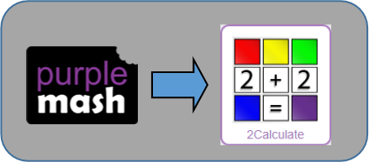

Key Vocabulary
Formula Wizard – The wizard guides you in creating a variety of formulae for a cell such as calculations, totals, averages, minimum and maximum for the selected cells.
Move cell tool – This tool makes a cell’s contents moveable by drag-and-drop methods.
Random tool – Click to give a random value between 0 and 9 to the cell.
Rows - Vertical reference points for the cells in a spreadsheet.
Spin Tool – Adds or subtracts 1 from the value of the cell to its right.
Spreadsheet - A computer program that represents information in a grid of rows and columns. Any cell in the grid may contain either data or a formula that describes the value to be inserted based on the values in other cells.
Timer – When placed in the spreadsheet, click the timer to adds 1 to the value of the cell to its right every second until it is clicked again.
Average – Symbols used to represent comparing two values
Advance mode – A mode of 2Calculate in which the cells have references and can include formulae.
Copy and Paste – A way to copy information from the screen into the computer’s memory and paste it elsewhere without re-typing.
Columns – Vertical reference points for the cells in a spreadsheet.
Cells – An individual section of a spreadsheet grid. It contains data or calculations.
Charts – Use this button to create a variety of graph types for the data in the spreadsheet.
Equals tool – tests whether the entered calculation in the cells to the left of the tool has the correct answer in the cell to the right of the tool.
Formula – Use the formula wizard or type into the formula bar to create a formula in a cell, this will calculate the value for the cells based upon the value of other cells in the spreadsheet.

PURPLE MASH COMPUTING SCHEME OF WORK - KNOWLEDGE ORGANISER
Unit: 5.3 – Spreadsheets
Key Questions
Key Images
Open the main menu
Save your work
Open a previously saved file
Increase or decrease spreadsheet size |  |  |  |  | 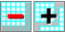
Advanced mode
Formula wizard
Format cell toolbox |  |  |  |  | 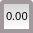
Charts |  |  |  |  | 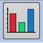
Totals toolbox
Image Tools
Controls Toolbox
Random number |  |  |  |  | Count |  |  | 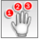
Equals |  |  |  |  | Timer
To copy | 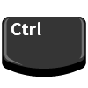+ | To cut | + |  |  | To paste | +

Click on the cell where you want the product to be displayed then click the formula wizard button. Click on the cell that contains the first number. Choose the x operation then click on the second number. Click OK.

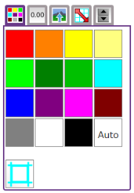
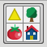
It represents the data of a situations for example budgeting for a party, working out how big a field needs to be for a certain number of animals, working out how to spend your pocket money over time. Using the existing data to predict what time your shadow will be a certain length etc.

Explain what a spreadsheet model of a real-life situation is and what it can be used for?
You could use formulae and the totalling tools. To make the spreadsheet easier to understand, you could use named variables.

What would you use in 2Calculate to have a cell that automatically calculates the number of days since a certain date?
How would you add a formula so that the cell shows the product of two other cells?

