St Mary’s C of E Primary School, Writhlington
‘Inspiring Learning Together’
Scheme of Work + Knowlegde Organiser
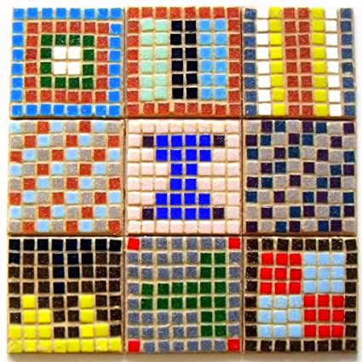
Key Vocabulary:
Spelling | Definition/Sentence
mosaic | Pictures and patterns made from tiny pieces of coloured stone
tesserae | tiny stones or tiles used to make a mosaic
mortar | a type of cement used to stick the tesserae to the floor.
motif | a decorative image or design, especially a repeated one forming a pattern
geometric designs | made from rectangles, squares and circles.
border | a strip forming the outer edge of something
hardie | a tool like a chisel, used to cut stones for mosaics

Knowledge outcomes:
Create sketch books to record their observations and use them to review and revisit ideas

Improve mastery of art and design techniques, including drawing, painting and sculpture with a range of materials [for example, pencil, charcoal, paint, clay]

Learn about great artists, architects and designers in history.

Wider Curriculum
Links to History topic – The Romans
The Learning Journey:
What is a mosaic?
Children will look at and identify the different features of Roman mosaics and will make rough drawings of ideas they like.
Can I design a mosaic border?
Children to develop and practice the technique of printing using a printing stick, experimenting with different patterns.
Can I design a mosaic?
After discussing the design criteria, children will plan their own mosaics, thinking about a simple design, colours and time available.
Can I create a mosaic?
Children will bring all their ideas together to create their own mosaics.
Can I evaluate my mosaic?
Children will discuss the process of making their own mosaic, thinking about what they found challenging and rewarding. They will think about what they could improve on and how.
Mosaics

