St Mary’s C of E Primary School, Writhlington
‘Inspiring Learning Together’
Stargazers – Earth and Space

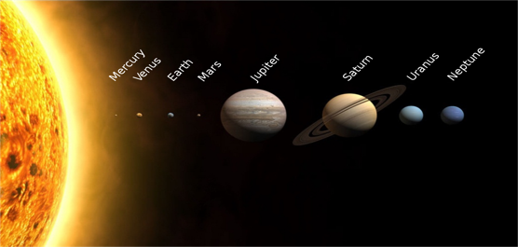
Key Vocabulary:
Axis – An imaginary line about which a body rotates
Celestial – positioned in or relating to the sky, or outer space as observed in the astronomy
Dwarf planet – a celestial body resembling a small planet but lacking certain technical criteria to be class as a planet
Geocentric – where people believe the Earth was at the center of the solar system
Heliocentric – representing the sun as the center of the solar system, the modern view of the solar system.
Moon – a natural satellite of any planet
Orbit – the regularly repeated oval course of a celestial obkect around a star or planet
Planet – a celestial body moving in orbit round a star
Sun – the star around which planets orbit.

The Learning Journey:
- Can I explain why we know the Sun Earth and Moon are spherical?
- Explore scientific evidence that supports that argument that the Earth is round.
- Can I name, describe and order the planets in our solar system?
- Children will be creating models of the solar system using playdoh
- Can I explain how planets move in our solar system?
- Children will be learning about how planets move through the geocentric versus heliocentric models, how did scientists discover how planets move.
- Can I explain day and night and the apparent moment of the sun across the sky?
- Children will understand that it is the Earth’s rotation that creates the appearance that the Sun is moving.
- Can I investigate night and day in different parts of the earth?
- Children will use a globe and a torch to explain day and night in different parts of the world.
- Can I explain the movement of the moon and demonstrate my understanding of the moon cycle?
- Children will be using oreo’s to create a diagram of the moons monthly cycle.

National Curriculum:
- Describe the movement of the Earth and other planets, relative to the Sun in the solar system.
- Describe the movement of the moon relative to the Earth
- Describe the Sun Earth and Moon as approximately spherical bodies
- Use the idea of the Earth’s rotation to explain day and night and the apparent movement of the sun across the sky.
Picture or illustration:

