St Mary’s C of E Primary School, Writhlington
‘Inspiring Learning Together’
Scheme of Work + Knowledge Organiser
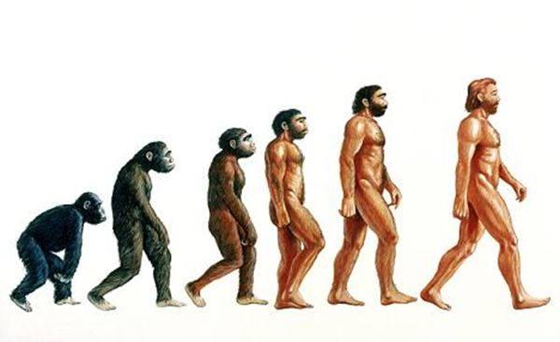
National Curriculum Knowledge outcomes:
I can recognise that living things have changed over time and that fossils provide information about living things that inhabited the Earth millions of years ago.

I can recognise that living things produce offspring of the same kind, but normally offspring vary and are not identical to their parents.

I can identify how animals and plants are adapted to suit their environment in different ways and that adaptation may lead to evolution.

Key Vocabulary:
Spelling | Definition/Sentence
Adaptation | The process of change so that an organism or species can become better suited to their environment
Body fossil | Preserved remains of the body of the actual animal or plant itself
Breeding | The mating and production of offspring by animals
Environment | The surroundings or conditions in which a person, animal, or plant lives
Evolution | The process by which different kinds of living organism are believed to have developed from earlier forms during the history of the earth
Fossil | The remains or impression of a prehistoric plant or animal embedded in rock and preserved
Inherit | To gain a quality, characteristic or predisposition genetically from a parent or ancestor
Offspring | A person’s child or children/ an animal’s young
Reproduction | The production of offspring by a sexual or asexual process
Selective breeding | The process by which humans use animal breeding and plant breeding to develop selective characteristics by choosing particular animals and plants
Trace fossil | Indirect evidence of life in the past such as the footprints, tracks, burrows, borings and waste left behind by animals

The Learning Journey:
Can I explain what a fossil is and what we can learn from them? Creating ‘fossils’.
Can I explain how fossils are formed?
Can I explain how human offspring can vary from the parents and why?
Can I explain how animal offspring can vary over time?
Create a documentary script – similar to David Attenborough- to explain adaptations.
Can I explain how animals and plants adapt to their environments?
Independent research to present findings to the class.
Can I explain some of the work of Charles Darwin?

Science – Evolution and Inheritance

