PURPLE MASH COMPUTING SCHEME OF WORK - KNOWLEDGE ORGANISER
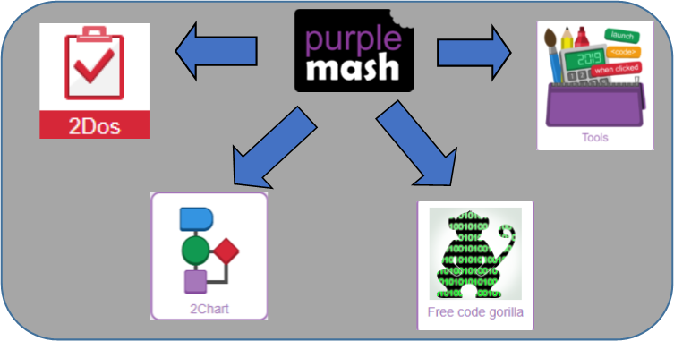
Unit: 5.1 – Coding
To represent a program design and algorithm.
To create a program that simulates a physical system using decomposition.
To explore string and text variable types so that the most appropriate can be used in programs.
To use the Launch command in 2Code Gorilla
To program a playable game with timers and scorepad.

Key Learning
Key Resources

If/Else - A conditional command. This tests a statement. If the condition is true, then the commands inside the ‘if block’ will be run. If the condition is not met, then the commands inside the ‘else block’ are run.
Input - Information going into the computer. Can include moving or clicking the mouse, using the keyboard, swiping and tilting the device.
Output - Information that comes out of the computer e.g. sound.
Object - An element in a computer program that can be changed using actions or properties. In 2Code, buttons, characters and vehicles are types of objects.
Repeat - This command can be used to make a block of commands run a set number of times or forever.
Sequence - This is when a computer program runs commands in order. In 2Code this can also include “repeat” or a timer.
Selection - This is a conditional/decision command. When selection is used, a program will choose a different outcome depending on a condition.
Simulation - A model that represents a real or imaginary situation.
Timer - Use this command to run a block of commands after a timed delay or at regular intervals.
Variable – A named area in computer memory. A variable has a name and a value. The program can change this variable value.

Key Vocabulary
Action - Types of commands, which are run on an object. They could be used to move an object or change a property.
Alert - This is a type of output. It shows a pop-up of text on the screen.
Algorithm - a precise step by step set of instructions used to solve a problem or achieve an objective.
Bug - A problem in a computer program that stops it working the way it was designed.
Code Design – Design what a program will look like and what it will do.
Command - A single instruction in a computer program.
Control - These commands determine whether parts of the program will run, how often and sometimes, when.
Debug/Debugging - Looking for any problems in the code, fixing and testing them.
Design Mode - Used to create the look of a 2Code computer program when it is run.
Event – Something that causes a block of code to be run.
Get Input - This puts the text that a user types into the computer’s temporary memory to be used to control the program flow.
If - A conditional command. This tests a statement. If the condition is true, then the commands inside the block will be run.

PURPLE MASH COMPUTING SCHEME OF WORK - KNOWLEDGE ORGANISER
Unit: 5.1 – Coding
Key Questions
Key Images
Open design mode in 2Code
Switch to code mode in 2Code
Add a new Tab to your code
Creating a variable in 2Code
Gorilla
Example of combining variables and strings to print to the screen
A change variable block
The Launch command block

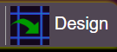
What does simulating a physical system mean?

Creating a program where the objects behave as they would in the real world. For example, a football program that uses angles, speed and friction to simulate kicking a football. When simulating a physical system, you first must break the system down into parts that can be coded (decomposition). The different parts will come together to make the full simulation.
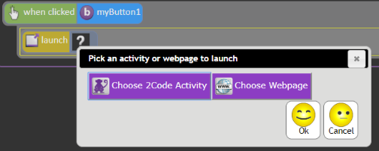
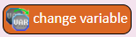
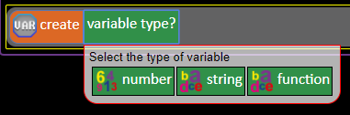
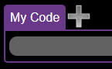
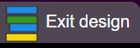
Clicking on a button or other object in the program to opens another 2Code program or a webpage.
Describe how you would use variables to make a timer countdown and a scorepad for a game.

Timer countdown: Create a timer variable and set it to the starting number of seconds. Add a Timer command that repeats and subtracts 1 every second. Add a text object in design view to display this number.
Score: create a variable to store the score, each time the user gains a point, change and display the value of the variable.
Give examples of how you could use the Launch command in 2Code.
What does selection mean in coding and how can you achieve this in 2Code?

