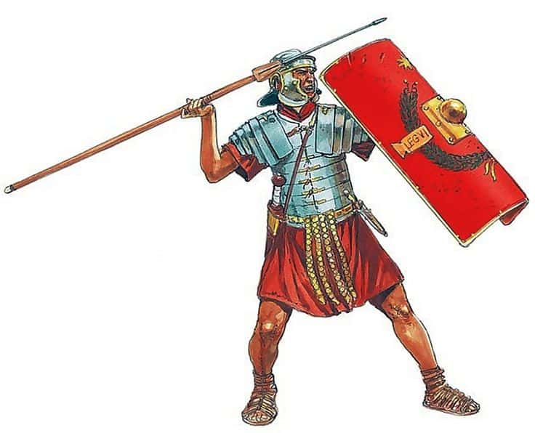
Year 3 Homework: Term 1
Our topic this term is the Romans. To help us with our learning,
please complete at least one of these tasks a week to be handed
in on a Friday.
- Draw or paint a picture of something from the Roman times, e.g. a Roman banquet or chariot racing. Write a description to go with it.
- Write a secret message in Roman numerals, with an alphabet key.
- Design and label a Roman outfit for a slave and/or rich person.
- Write a food diary for a day as if you were a member of a Roman household.
- Design a job advert for someone to work as a servant in a Roman villa.
- Create a maths worksheet for Roman children, making sure you use Roman numerals in your calculations.
- Find as many countries as possible that the Romans invaded. Draw their flags and write a sentence to go with each flag.
- Design, and make if possible, a Roman shield using Roman styles and colours.
- Create a Roman timeline of key events.
- Write a short newspaper report announcing the Roman invasion of Britain.
- Find an interesting paragraph about Roman life in a book. Make notes and write about it in your own words.
- Research Roman Gods and then design and label your own.
- Find a Roman recipe. Create this recipe and take a photo to show your creation. Make sure you put a copy of the recipe in your homework folder.

