St Mary’s Primary School and Nursery
‘Be the best you can be’

Computing Scheme of Learning

This document contains an overview of the units included in the Purple Mash Computing Scheme of Work for all year groups. Please refer to separate documentation on how the Early Years Curriculum is supported by Purple Mash at St Mary’s.
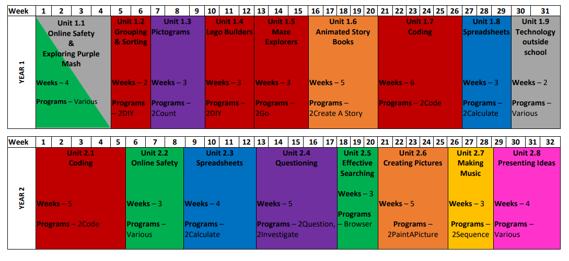

Key Stage 2
