**St Mary’s C of E Primary School, Writhlington**

*‘Inspiring Learning Together’*

**Scheme of Work + Knowlegde Organiser**

**Key Vocabulary:**

|  |  |
| --- | --- |
| **Spelling** | **Definition/Sentence** |
| **equator** | an imaginary line which divides the earth into two parts, the Northern and Southern hemisphere |
| **Tropic of Cancer** | an imaginary line which runs north of the equator |
| **Tropic of Capricorn** | an imaginary line which runs south of the equator |
| **climate** | the average measurements of temperature, wind, humidity, snow, and rain in a place over the course of years |
| **deforestation** | the clearing, or cutting down, of forests |
|  |  |
|  |  |

**Knowledge outcomes:**Identify the position and significance of Equator and the Tropics of Cancer and Capricorn

Describe and understand key aspects of: physical geography, including: climate zones, rivers, mountains, volcanoes and earthquakes, and the water cycle

Use maps, atlases, globes and digital/computer mapping to locate countries and describe features studied

**The Learning Journey:**

**Can I locate the Amazon rainforest?**

This lesson will elicit children’s knowledge about the rainforest and look at the location of rainforests around the world.

**What is the rainforest climate like?**

Children will create weather forecasts for the Amazon rainforest and learn the difference between climate and weather.

**Can I describe and understand the features of the layers of a rainforest?**

Children will look at the different layers of the rainforest, creating their own for the classroom.

**Can I research different animals living in the Amazon?**

Children will create fact files for different rainforest creatures.

**What is deforestation and what effects does it have on our rainforests?**

Children will consider both the positive and negative effects of deforestation on the rainforest from different perspectives.

**Can I suggest ways to help save our rainforests?**

Children will take part in a scavenger hunt to look for different ways to help save the rainforest. In groups, children will create an information page to promote ways to save our rainforests.

**Wider Curriculum**   
Links to Art and Design and Technology

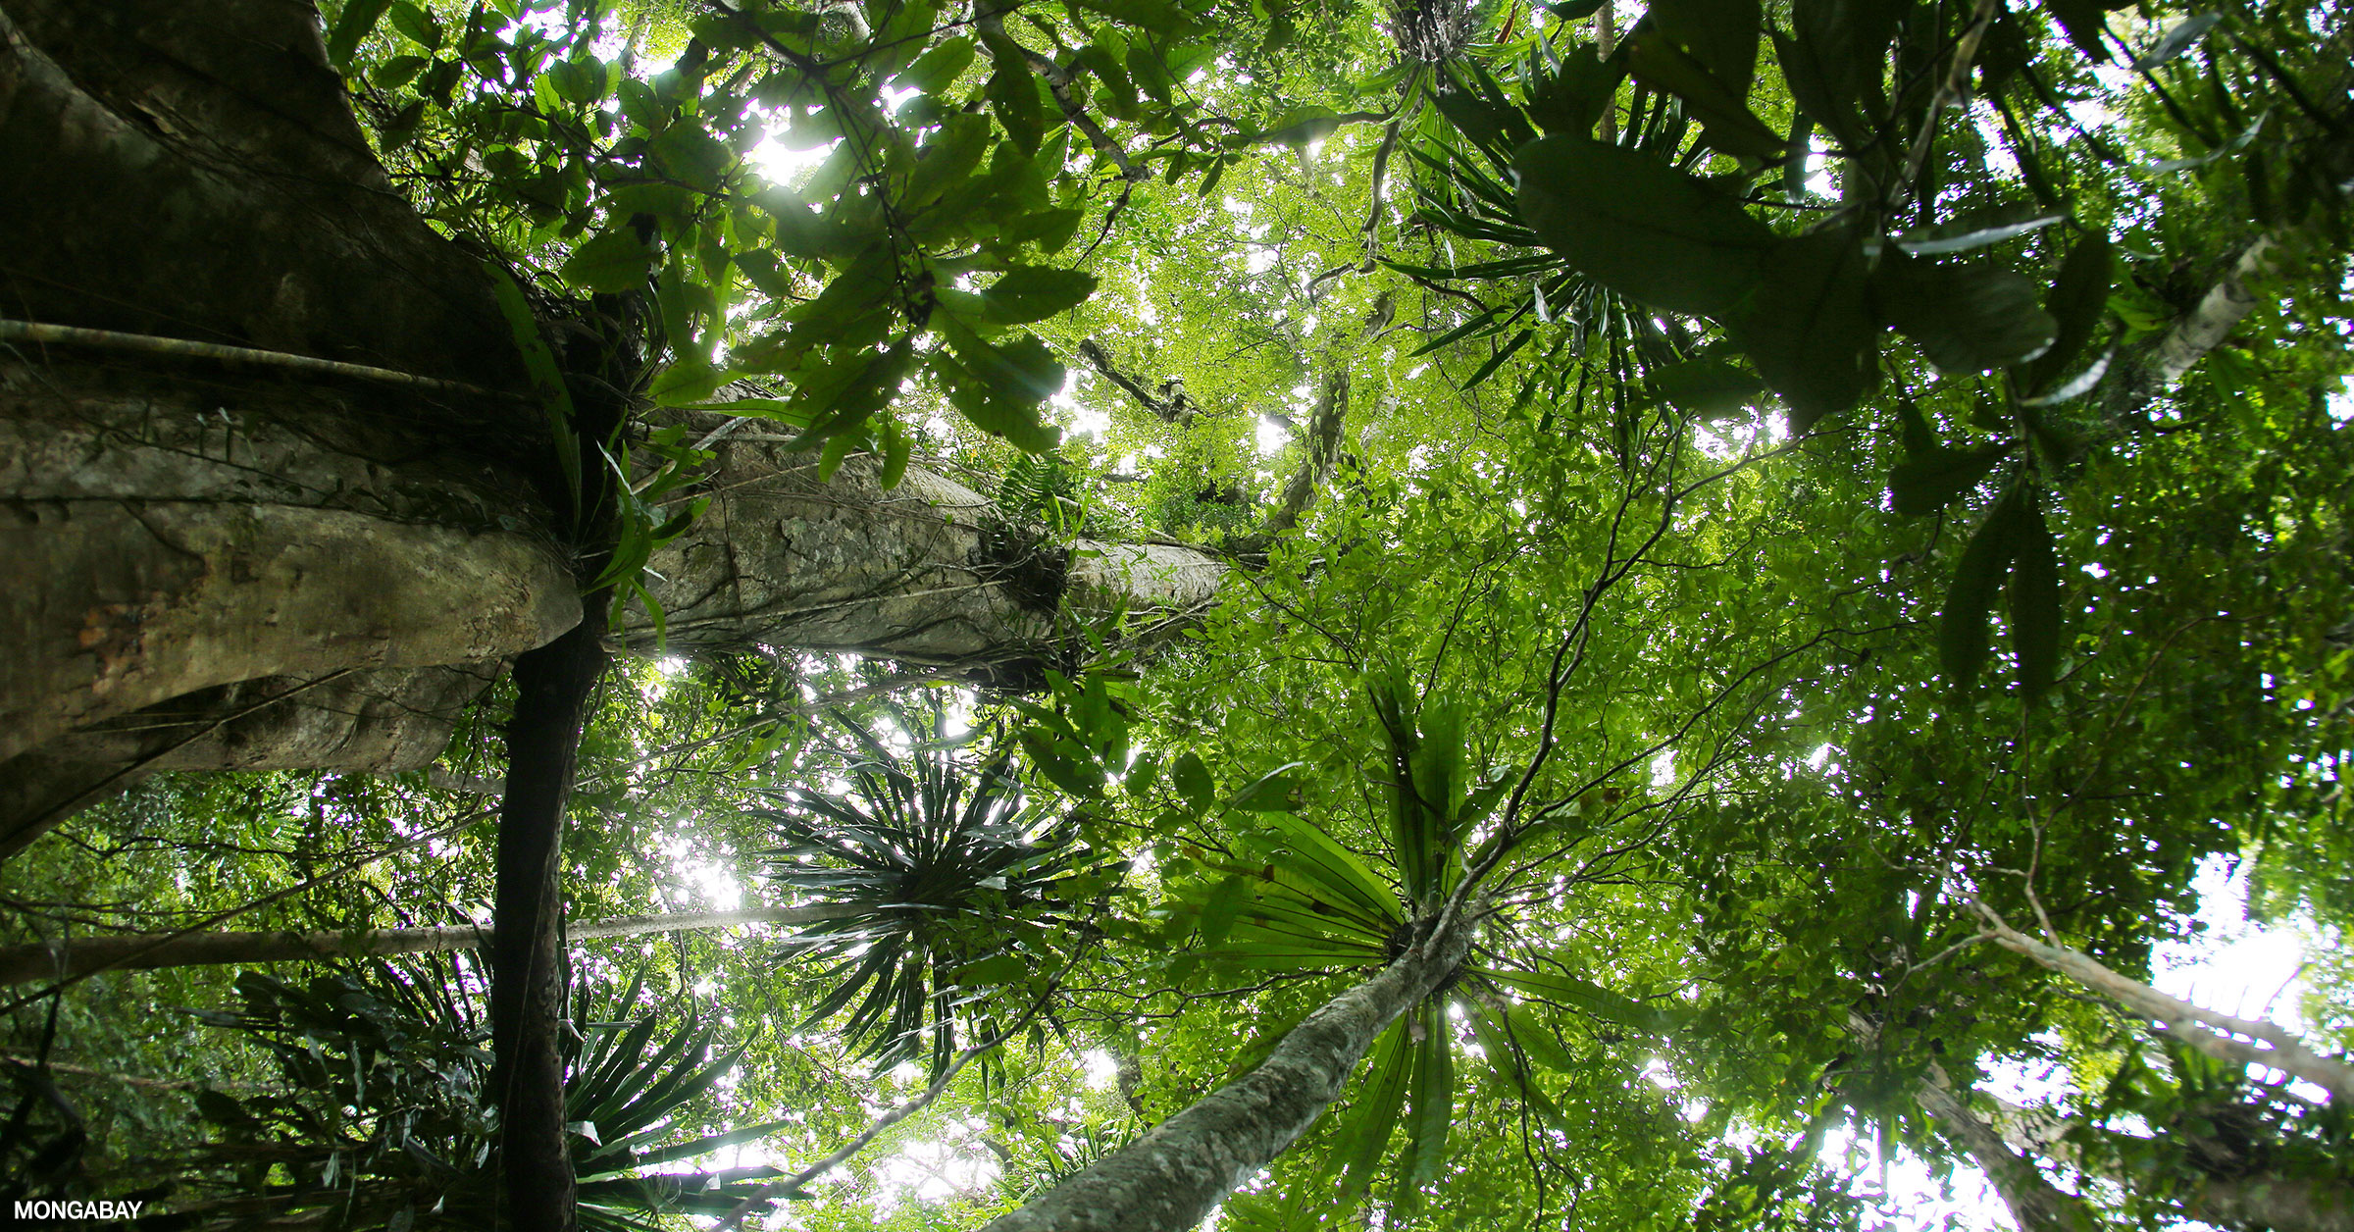

**South American Rainforest**