St Mary’s C of E Primary School, Writhlington
‘Be the best you can Be’
Scheme of Work + Knowlegde Organiser
Sculpture
The Learning Journey:
LQ: How do sculptures improve the environment?
- Children will make thoughtful observations about how sculptors and others work to improve the quality of an environment
LQ: Can I record first hand observations to develop ideas using a sketch book?
- Children will choose an nearby area and talk about its design and purpose
LQ: Can I explore ideas for a site-specific sculpture?
- Children in small teams develop their ideas for a design based on improving a chosen area.
LQ: Can I investigate and combine different materials for a purpose?
- Children to make a small-scale sculpture experimenting with different ways of assembling and combing materials.
LQ: Can I develop control of tools and techniques?
- Children to continue to explore texture, shape and colour as they form their sculpture.
LQ: Can I compare ideas, methods and approaches of our work?
- Children to evaluate the effectiveness of their sculpture.
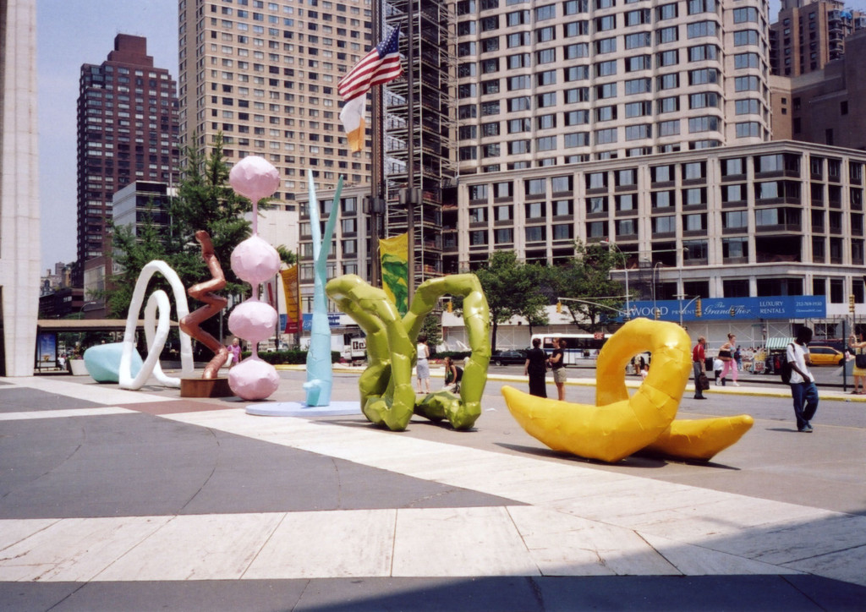
National Curriculum:
to create sketch books to record their observations and use them to review and revisit ideas
to improve their mastery of art and design techniques, including drawing, painting and sculpture with a range of materials [for example, pencil, charcoal, paint, clay]
about great artists, architects and designers in history.
Wider Curriculum (Cooking, trips, outdoor):
Kilve court
Key Vocabulary:

Composition
Cubism
Culture
Form
Media/medium
Perspective
Presentation
Scale
Shape
Subject
Sculpture
maquette

