St Mary’s C of E Primary School, Writhlington
‘Inspiring Learning Together’
Scheme of Work + Knowlegde Organiser
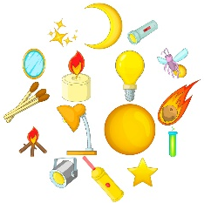
Key Vocabulary:
Spelling | Definition/Sentence
light | a brightness that lets you see things
dark | the absence of light
reflect | sent back from the surface and not pass through
torch | a small electric light powered by batteries
mirror | a flat piece of glass which reflects light so that you can see your reflection
opaque | something which you cannot see through
translucent | allows light through, but not in detailed shapes
transparent | allows light to pass through so that objects can be directly

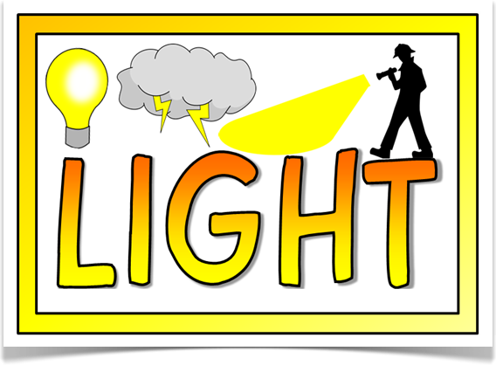
Wider Curriculum (Cooking, trips, outdoor):
Links to PSHE and sun safety
The Learning Journey:
Can I identify a range of different light sources?
Children will discuss the difference between light and dark, using these ideas to sort different objects into light and non-light sources.
Which surfaces reflect light?
Children will design their own reflective backpack for cyclists to wear when riding in the dark. They will conduct an experiment to identify the best reflective material to use.
How do mirrors work?
Children will discover and discuss the characteristics of reflective surfaces by playing mirror games.
What are the benefits and dangers of the sun?
Children will explore the idea of UV light and its effects. They will create an information poster to explain how people can stay safe whilst enjoying the sunshine.
Which materials block light to form shadows?
Children will conduct an experiment to determine which material best blocks light. Using these ideas they will design their own pair of curtains.
How do shadows change?
This lesson will take place outside, where children will investigate the concept of shadows and why they change.
Knowledge outcomes:
Recognise that light is needed in order to see things and that dark is the absence of light
Notice that light is reflected from surfaces
Recognise that light from the sun can be dangerous and that there are ways to protect our eyes
Recognise that shadows are formed when the light from a light source is blocked by an opaque object
Find patterns in the way that the size of shadows change
Let There Be Light!

