St Mary’s C of E Primary School, Writhlington
‘Inspiring Learning Together’
Scheme of Work + Knowlegde Organiser
Key Vocabulary:
Spelling | Definition/Sentence
volcano | a mountain or hill, typically conical, having a crater through which lava and gas erupt from the earth's crust
earthquake | a sudden violent shaking of the ground, typically causing great destruction, as a result of movements within the earth's crust or volcanic action
tsunami | a long, high sea wave caused by an earthquake or other disturbance
tornado | violently rotating winds which have the appearance of a funnel-shaped cloud
hurricane | a storm with a violent wind
Ring of Fire | major area in the Pacific Ocean where many volcanoes and earthquakes occur

The Learning Journey:
What’s underneath my feet?
Children will think about what is underneath their feet, exploring the structure of the earth’s core.
How are volcanoes formed?
Children will explore the different ways tectonic plates move and how this can cause the formation of a volcano.
How do volcanoes affect people’s lives?
Children will discuss the location of the earth’s volcanoes and the definitions active, dormant and extinct. Having a classroom debate, children will consider the pros and cons of living near a volcano.
What causes earthquakes and how to can you stay safe?
Children will explore how earthquakes occur and follow the safety procedures recommended in an earthquake.
What causes tsunamis and how do they affect people’s lives?
Children will look at a picture after it has been hit by a tsunami and consider the damage and help needed. They will use iPads to investigate the Boxing Day tsunami in 2004.
What causes tornadoes and how they are formed?
Children will make their own tornado in a bottle and consider how the Ef level of a tornado affects the amount of disruption caused.
What causes hurricanes and how do they affect people’s lives?
Children will look at where hurricanes are most likely to occur in the world. Is there a link between another natural disaster?

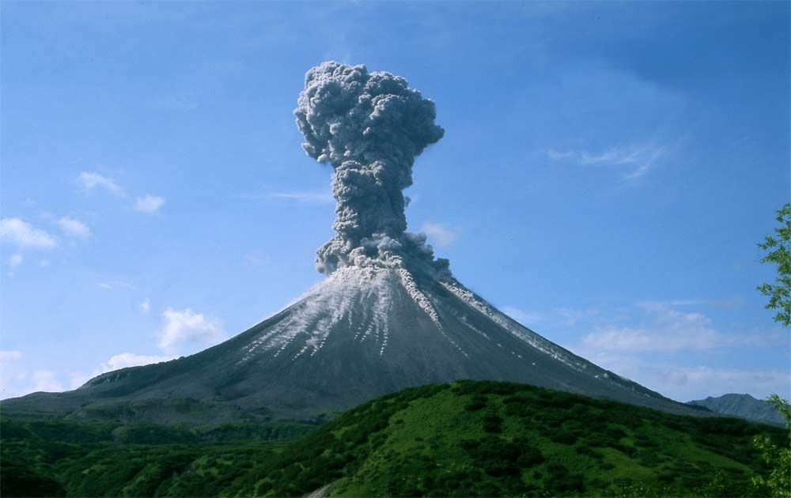
Natural Disasters
Wider Curriculum (Cooking, trips, outdoor):
Links to English and Escape From Pompeii text
Knowledge outcomes:
- Describe and understand key aspects of physical geography, including volcanoes, earthquakes, tsunamis and hurricanes
- Describe how natural disasters affect people’s lives
- Understand and discuss the structure of the earth
