St Mary’s C of E Primary School, Writhlington
‘Inspiring Learning Together’
Scheme of Work + Knowlegde Organiser
Key Vocabulary:
Spelling | Definition/Sentence

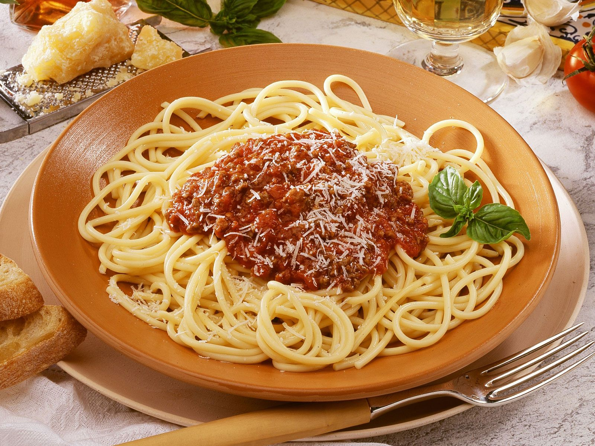
Wider Curriculum (Cooking, trips, outdoor)
Cooking and healthy eating
The Learning Journey:
Can I research the ingredients in a spaghetti Bolognese?
Children discuss the importance of healthy diets and look at a range of different Bolognese recipes.
Can I design my own spaghetti Bolognese?
Based on children’s own tastes and ideas, they will design their own Bolognese, drawing pictures, annotating and writing an ingredients list.
Can I make my own spaghetti Bolognese?
Can I evaluate my own and others food?
Children to taste a range of different spaghetti bologneses, evaluating their own and others and suggesting ways to improve.
Can I write my own recipe and instructions for a spaghetti Bolognese?
Knowledge outcomes:
Use research to inform the design of innovative, functional, appealing products that are fit for purpose, aimed at particular individuals or groups
Generate, develop, model and communicate their ideas through discussion and annotated sketches
Understand and apply the principles of a healthy and varied diet
Prepare and cook a variety of predominantly savoury dishes using a range of cooking techniques
Investigate and analyse a range of existing products
Evaluate their ideas and products against their own design criteria and consider the views of others to improve their work
Healthy Eating – Spaghetti Bolognese

