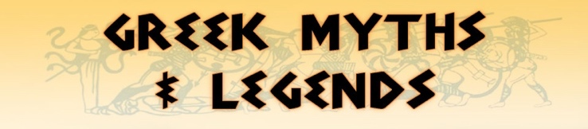

**Class 6 Newsletter**

**Term 1 2020**

WELCOME TO YEAR SIX!   
  
This is our first Class 6 newsletter of the year and so we would like to wish all our children, parents and carers a very warm welcome back after the Summer holidays. We hope you all had a lovely break. This year will be a very different year but hopefully an exciting too with the different learning opportunities and experiences that the new topics will bring. Year 6 is an important year and we will be looking for the Year 6s to be the amazing role models that we know they can be. We understand that there may be many feelings surrounding the return to school, given the current circumstances, however it’s important that we all work together to make the return as smooth as possible.

We know that at times there may be a need to pass on a quick message before school, however due to social distancing it may not always be possible in the morning so you can either phone and leave a message or email the office at [office@stmaryswrithlington.co.uk](mailto:office@stmaryswrithlington.co.uk). Alternatively, please feel free to write a note for your child to pass on to us.

As ever, if you have any worries or questions relating to your child and need a little more time, please do not hesitate to arrange a time to talk. It is important for us all that your children are happy at school, so please keep us informed of any concerns, no matter how small. May we take this opportunity to thank you for your continued support.

Miss Golden and Mrs Sillem

What we are learning  
Our topic this term is ‘Myths, Minotaurs and Mazes!’ We will be learning about the history of the Ancient Greeks and what life was like, their achievements and their influence on the western world. We will be continuing to develop chronologically secure knowledge and understanding of British history as well as developing our skills of using an atlas and reading maps.

In English, we will be studying myths and legends and creating our own using many of the mythical creatures, such as the minotaur, as characters. This will help us to develop our descriptive writing.

We shall also be reading some poetry by Rachel Rooney and creating our own.

In Art, we will be developing our drawing techniques Mythical Me in the style of Henry Moore.

Our unit in Science is learning about animals and humans, including about different parts of the systems in our body and the way they function.

In RE we shall be asking the question ‘what does it mean if God is loving and holy?’ We will be exploring this Christian unit and will be continuing to develop respect and inquisitiveness through their continuing enquiry and exploration in RE. Our school value this term is friendship and we will be discussing this a lot in class.

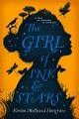

Useful Information

**PE**

Our regular PE days will be every Tuesday and Friday. Due to the current circumstances, children are to wear their PE kit in to school on these days to save changing. The PE kit should include a white t-shirt, black shorts and daps for outdoor activities. The children may also wear a tracksuit for outdoor PE in the colder months but no hoodies please.

**Homework**

For the first term, the class’ homework will be project and presentation about a hobby of theirs. Each week your child should choose one aspect of it to complete and bring back. In the final week of term, they will deliver a short presentation to the class (around 3 minutes) displaying all of their work over the term. Also, each week, there will be spellings and times tables to be practiced which will be given on a Monday for a test on the Friday of that week.

Pencil cases

As we are trying to limit the number of items being brought in to school, pupils will have their own set of resources for them to use in their trays – pencils, pen, ruler, rubber, etc. As it’s important that these are not shared, pupils do not need to bring in their own pencil cases.

Water Bottles

It is very important that the children have fresh water each day and whilst we have a water fountains in school, it is much more convenient to have a water bottle to hand in the classroom. Please can you ensure your child has one in school, with their name on, which they will need to take home each evening to wash and refill.

Reading

A big focus this year in year 6 and across the school is reading for pleasure, we are also looking to develop stamina and speed in reading alongside understanding what they have read. To support this, we are asking that every child continues to read 5 times a week, which can be your child reading to you or independent reading.

Please also remember to sign your child’s reading record and ensure it is brought into school at least every Friday. We have a reading reward system, so that children are recognised for their efforts in reading at home.

We are very excited to have set up a new reading scheme across Key Stage 2 called

‘Accelerated Reader’ with a lot of new books. There will be more information coming

soon!

This term, our class book will be: The girl of ink and stars by Kiran Millwood – a magical

book about friendship, adventures, myths and courage.