St Mary’s C of E Primary School, Writhlington
‘Inspiring Learning Together’
Scheme of Work + Knowlegde Organiser
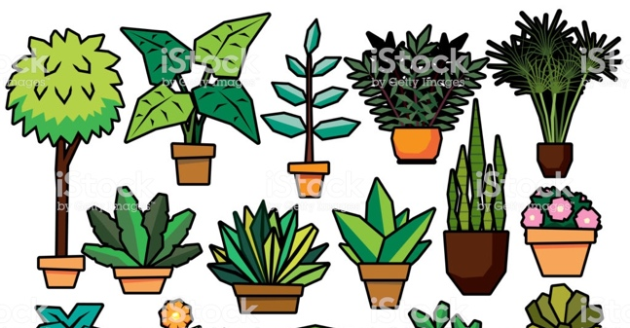
Key Vocabulary:
Spelling | Definition/Sentence
nutrients | A substance that provides nourishment essential for life and growth
transport | Take or carry from one place to another
pollination | The transfer of pollen to allow fertilisation
fertilisation | The action or process of fertilizing an egg or a female animal or plant
dispersal | The process of spreading things over a wide area
germination | The development of a plant from a seed

The Learning Journey:
Can I name the different parts of a plant and explain their jobs? Children to look at a range of plants, identifying their different parts and job roles.
What do plants need to grow?
Children will look at what plants need to grow and conduct a comparative experiment, placing plants in different growing conditions in order to see which plant grows the most.
What do my results show?
Children will record their data, discuss their results and present them in a bar chart.
Can I investigate how water is transported in plants?
Children will complete another comparative experiment, looking at the effect of temperature on water transportation.
Can I explain the different roles in pollination and fertilisation?
Children will dissect tulips in order to identify the different parts and their roles in pollination and fertilisation.
Can I order the stages of the life cycle of a flowering plant?
Children to act out the different methods of seed dispersal in order to aid their understanding of the plant life cycle.
Wider Curriculum (Cooking, trips, outdoor):
Links to our topic – The South American Rainforest!

Knowledge outcomes:
Identify and describe the functions of different parts of flowering plants: roots, stem/trunk, leaves and flowers

Explore the requirements of plants for life and growth (air, light, water, nutrients from soil, and room to grow) and how they vary from plant to plant

Investigate the way in which water is transported within plants

Explore the part that flowers play in the life cycle of flowering plants, including pollination, seed formation and seed dispersal
Plants – Watch Us Grow!

