St Mary’s C of E Primary School, Writhlington
‘Inspiring Learning Together’
Scheme of Work + Knowlegde Organiser
Knowledge outcomes:
Ask questions and answer using different scientific enquiries
Complete practical enquiries, comparative and fair tests
Make observations using a range of equipment
Gather and present data in a range of different ways
Report on findings from enquiries
Draw simple conclusions, identifying differences and similarities
The Learning Journey:
Why do some objects float, and others sink?
Linking to their topic of the Titanic, children will investigate the buoyancy of different objects.
Can I design my own boat?
Based on their learning from the previous lesson, children will design their own boat, thinking about material and shape.
Can you drop an egg without breaking it?
Children will experiment wrapping eggs in different materials in order to investigate whether the egg will break.
Which liquids melt the fastest?
Children will predict and experiment which liquids will melt the fastest.
Wider Curriculum
Links to Topic – The Titanic!
Key Vocabulary:
Spelling | Definition/Sentence
buoyancy | a force on an object making that object rise or move upward
weight | the measure of the force of gravity on an object
up thrust | the upward force that a liquid exerts on a body floating in it
surface area | total exposed area inside a given boundary
fair test | a test which controls all but one variable when attempting to answer a scientific question
prediction | say or estimate what will happen in the future

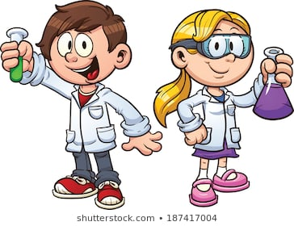

We Are Scientists!

