St Mary’s C of E Primary School, Writhlington
‘Inspiring Learning Together’
Scheme of Work + Knowledge Organiser
Wider Curriculum (Cooking, trips, outdoor):
Trip to a castle (e.g Nunney Castle)

The Learning Journey:
- Can I compare Stone Age life with life today?
- Can I compare life of the first farmers to the start of the Iron Age?
- What can I learn about the ways the Romans improved the way they lived through building stone houses and using drainage?
- Can I identify and explain the features of a castle?
- Can I explain how the Black Death affected farmers and other people in Britain?
- What do I understand how life was different for rich and poor people hundreds of years ago?
- Can I understand the major changes that have occurred from the Stone Age till now regarding Staying Full, Staying Warm, Staying Clean?
National Curriculum Knowledge outcomes:

...all children should be able to:
understand that how people have lived has changed through the years and give some examples.

...most children will be able to:
explain how people were able to stay warm, stay full and stay clean at some of the different times in history giving examples.

..some children will be able to:
make comparisons between different times in history giving examples of how people stayed, clean, warm and fed.

Key Vocabulary:
Spelling | Definition/Sentence
Stone Age | a period in prehistory during which early humans started using stones, usually flint, to make tools and weapons. It is the earliest known period of human culture
Iron Age | the time period (from approximately 500 BC to 43 AD in Britain) where iron became the preferred choice of metal for making tools. In Europe, The Iron Age marks the end of prehistory after the Stone Age and the Bronze Age
hunter gatherer | refers to how a group of people get their food. They find it growing wild or hunt and fish for it. They do not grow any food. Another name for a hunter/gatherer is a nomad. As early humans left Africa and spread throughout the globe, they found fruits and nuts that were edible.
nomad | a person who moves from place to place. Long ago, before the development of farming and cities, many people were nomads. They moved from one area to another in search of food for themselves or for their animals.
catapult | a type of machine used as a weapon to throw rocks or other things such as hot tar, that would cause damage to something else.
farmers | people who grow plants or raise animals
Romans | a citizen of ancient Rome or of the Roman Empire
castle | are a type of home that was built to protect the people inside. People who lived in the castle included lords as well as soldiers to defend it from enemy invaders
Black Death | a terrible disease that spread throughout Europe from 1347 to 1350. There was no cure for the disease and it was highly contagious

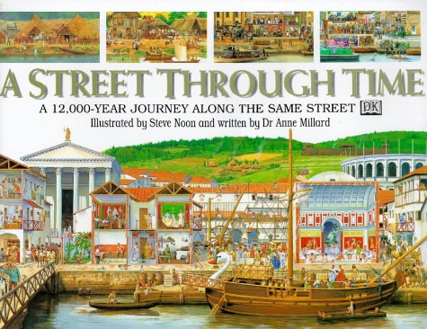
Class 1: A Street Through Time

