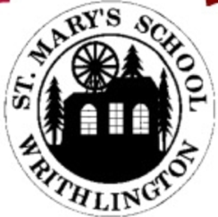



**Class 3 Newsletter**

**Term 3 2021**

**v**

Happy New Year!

Happy New Year to all of the children in Class 3 and their wonderful families. I hope that you had an enjoyable Christmas break and managed to spend some time relaxing, the children certainly deserved it. Term 3 is a busy and exciting term for the children with lots to look forward to, we hope you are ready!

Dates for this term

Due to the coronavirus pandemic, dates for this term are uncertain. Any important dates which do become set for the children will be communicated accordingly.

5th January – Term 3 begins

12th February – Term 3 ends

Our Learning

This term is book term and we will be   
 jumping into the magical world of a Narnia whilst reading The Lion, The Witch and The Wardrobe by C.S. Lewis. This terms English will revolve all around this text – we have many exciting things planned!

This term in Geography we will be developing our map skills with our topic ‘Marvellous Maps’. This will involve lots of outside adventures and creating our own magical maps of Narnia.

In Maths, children will develop their understanding of multiplication and division. This will help them to achieve their Spring Term 1 KIRF – the 4 times table.

Our topic for Science this term is ‘Let There Be Light!’ We will explore different light sources, the benefits and dangers of the sun and conduct experiments about shadows.

In Art, we will be looking at the work of famous artists. In particular, we will research Pablo Picasso and his artwork, before having a go at creating our own piece of artwork linked to Narnia, using his unique style.

In R.E. we shall be asking the question ‘What does it mean to belong to a religion?’ where we will be exploring Islam.

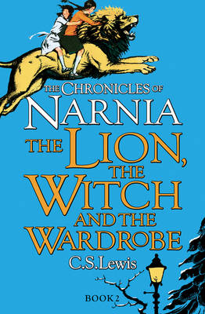

Useful Information

P.E. this term will take place on Wednesday and Thursday. Please ensure children come into school wearing P.E. kit on these days. These sessions may take place outside so please ensure that children have something warm to wear.

The children have a termly overview of the homework they are required to complete stuck in their books. Please ensure they learn the correct spellings for the week and complete at least one homework task from the termly overview. Homework will continue to be collected in on a Friday.

Please ensure that children are bringing their reading record in with them every day and that they are reading five times a week. These are checked weekly.

Please ensure that your child brings a coat with them every day. This will allow us to enjoy time outside even when the weather is against us.

KIRF: SPING Term 1

## I know the multiplication and division facts for the 4 times tables.

## 4 times table with games at Timestables.co.uk4 Times Tables & Division Facts Pocket Prompts |10 Cards

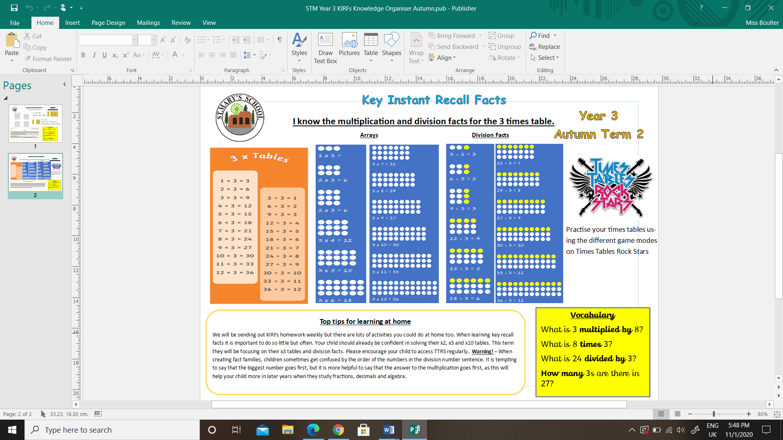

Practise your KIRF   
using TTRS.

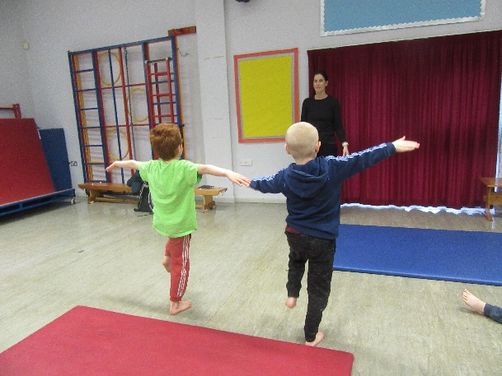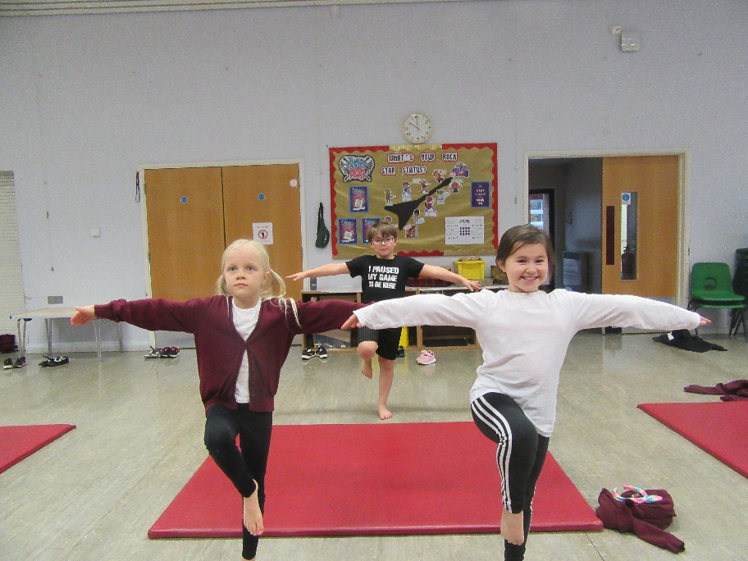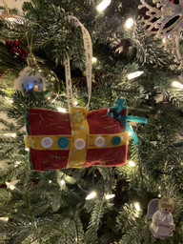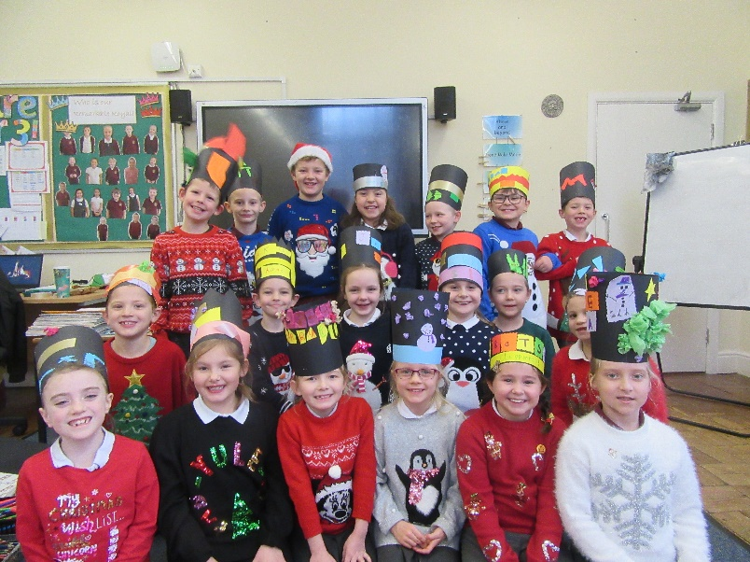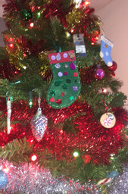

A celebration...

## Term 2 was a brilliant term in Class 3, we thoroughly enjoyed ourselves! Please enjoy a selection of photos taken across the term, including our Christmas celebrations and decorations.

**Vocabulary:**What is 4 ***multiplied*** by 8?  
What is 8 ***times*** 4?   
What is 32 divided by 4?   
***How many*** 4s are there in 32?