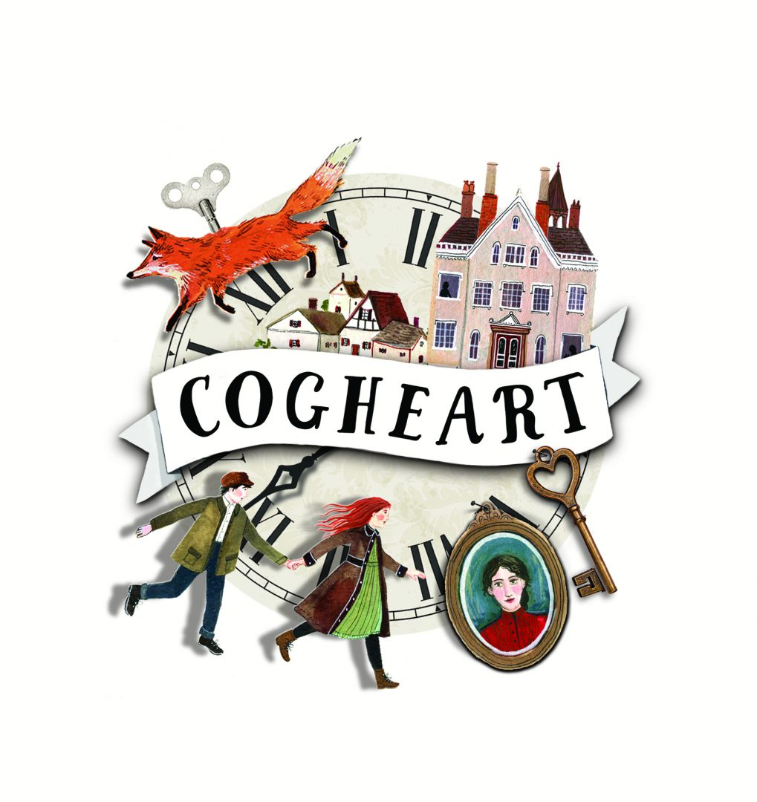

Class 6 Newsletter

Term 3 2021

Happy New Year!   
I hope you all had a wonderful rest over Christmas with family and friends. Term 3 is a busy one as we start off the year 2021 with plenty of learning.

What we are learning  
Our topic this term is based around the book ‘Cogheart’ by Peter Bunzl. It is fictional book set in 1896 in a Victorian England but with an alternative history: steampunk, mechanical animals, clockwork servants and silver airships. It follows the adventures of a heroine called Lily sets out on a journey to find the truth about her father.

We will be developing our descriptive writing and building on our grammar and punctuation knowledge using the book as inspiration.

In art we will be creating our own ‘Mechanimals’ based on our class book. Our unit in Science is ‘Light’. This will involve planning our own investigations, taking measurements and recording data and using scientific evidence to support ideas.

In RE, we will be learning about the enquiry question: How should we live and who can inspire us? The children will be continuing to develop respect and inquisitiveness of other faiths and traditions.

We will be learning about different cultural customs throughout history in our geography lessons.

Our school value this term is perseverance and we will be discussing this in whole school and key stage worships.

Dates for this term

Useful Information

**PE**

Our regular PE day will be every Tuesday with Mr Pile. Please can you make sure that your child wears their PE kit in to school on this day to save changing. The PE kit should include a white t-shirt, black shorts and daps for outdoor activities. The children may also wear a tracksuit for outdoor PE in the colder months but no hoodies please.

**Homework**

This term, homework will be sent out each Friday and will be due in the following Friday. The pieces which will be sent out will be from their SATs revision guides. It is important that pupils are bringing their revision guides in each day and are completing their homework as it will help them to reinforce the learning in class.

Spellings will continue to be given on a Monday for a test on the Friday of that week.

…and finally

As ever, if you have any worries or questions relating to your child and need a little more time, please do not hesitate to arrange a time to talk. It is important for us all that your children are happy at school, so please keep us informed of any concerns, no matter how small. You can contact me via email: lgolden@stmaryswrithlington.co.uk May we take this opportunity to thank you for your continued support.

Miss Golden and Mrs Sillem

Winter Weather

Now the weather is a lot colder, please ensure your child comes to school every day with a warm, waterproof named coat. (Hoodies are not part of the school uniform.)   
To take advantage of our amazing school grounds, it would be brilliant if each child has their own pair of wellies in school which they can wear at lunch times on the field.

Reading

There has been an increase in the number of times Class 6 have been reading at home since September – fantastic! Reading has been proven to have many, many benefits including: improving concentration and vocabulary, developing imagination and teaches us about the world around us. I’m sure you would agree that it is a valuable skill!

Please continue helping your child to read at home and sign their reading record so they are recognised and rewarded for their efforts in reading at home. Here are some questions you can ask your child about what they’ve read:

|  |  |
| --- | --- |
| **Predict it!** | …predict what might happen from what you have read?  *What happened first?*  *Next? After that? Finally? Why?* |
| **Understand it!** | …explain the meaning of the more difficult words in the book?  *What does ….mean?*  *Which word means the same as…?* |
| **Find it!** | …pick out information or key details from the book?  *Which words….?*  *Who? When? Where? What?* |
| **Summarise it!** | …tell you the main points in an information book?  *What have you learned from this page?*  …talk about the main parts of the story?  *What is this paragraph or chapter about?* |
| **Think**  **about it!** | …think about what has happened in the book and give reasons why?  *Which words tells you that….?*  *How is the character feeling? How do you know?* |
| **Link it!** | …talk about how things in the book link together?  *What are the themes in the book? What is the big idea?* |
| **Listen**  **to it!** | …talk about why the writer has chosen words and phrases?  *How does the book make you feel? Why?*  *Are there parts of the book that you really enjoyed? Why?* |
| **Compare it!** | …talk about different parts of the story or characters?  *How do the characters change in the story?*  *Does this book remind you of other stories that you have read?* |