St Mary’s C of E Primary School, Writhlington
‘Inspiring Learning Together’
Scheme of Work + Knowledge Organiser
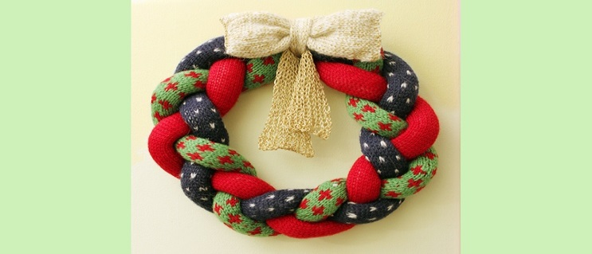
Wider Curriculum (Cooking, trips, outdoor):
Thinking about cost and profit when selling an item.
Making items to sell for Christmas
National Curriculum Knowledge outcomes:
- use research and develop design criteria to inform the design of innovative, functional, appealing products that are fit for purpose
- generate and communicate their ideas through discussion and annotated sketches.
- select from and use a range of materials and components, including textiles according to their functional properties and aesthetic qualities
- evaluate their ideas and products against their own design criteria and consider the views of others to improve their work

The Learning Journey:
LQ: Can I design a Christmas wreath?
Discuss the design process and look at other wreaths and their purpose.
LQ: Can I complete a slip stitch?
Experiment with different sewing stitch techniques.
LQ: Can I evaluate my wreath?
Finishing the design process to think about the product which has been designed and made and think about changes for future products.

Key Vocabulary:
Spelling | Definition/Sentence
Criteria | Guidelines for the finished product
Slip stitch | A loose stitch
Function | The use of the product
User | Who the product is designed for
Wadding | Soft, thick material used to line material
Assemble | To put together

Topic: DT

