St Mary’s C of E Primary School, Writhlington
‘Inspiring Learning Together’
Scheme of Work + Knowlegde Organiser
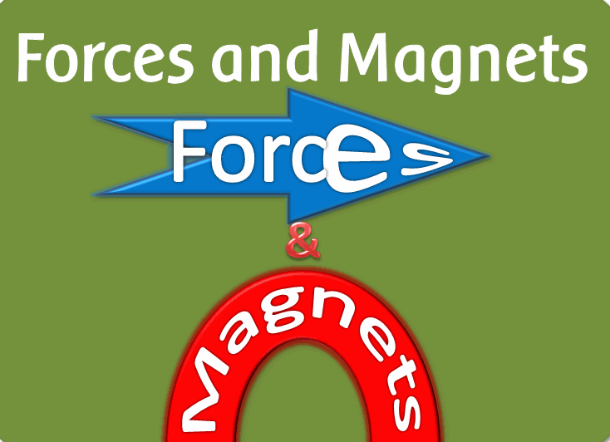
Key Vocabulary:
Spelling | Definition/Sentence
Force | A push or pull acting on an object
Direction | A course along which something moves
Strength | How strong something is
Forward | A direction that is facing or travelling towards the front
Backwards | A direction that is facing or travelling towards the back
Magnet | An object which produces an area of magnetic force around itself
Attract | Exert a force on an object that is directed towards the source
Repel | A drive or force back or away
Predict | Say or estimate what will happen

Wider Curriculum: PE and movement
The Learning Journey:
Which forces act upon objects?
Children receive a letter from a scientist who requires their help with science. Children investigate push and pull forces.
Which materials are magnetic?
Children to sort different household items depending on whether they are magnetic or not.
Do different conditions effect the strength of a magnet?
Children to consider what might effect the strength of a magnet. Using some of these ideas, children to design their own experiment to test a prediction.
Can I investigate the effects of friction on different surfaces? Children to use toy cars to test some fabrics create more friction than others.
Can I use my knowledge of magnets to design and create a game?
Children to design their own magnet game, thinking about the material they mat use, the time available and the amount of detail to their game.
Knowledge outcomes:
Compare how things move on different surfaces
Notice that some forces need contact between two objects, but magnetic forces can act at a distance
Observe how magnets attract or repel each other and attract some materials and not others
Compare and group together a variety of everyday materials on the basis of whether they are attracted to a magnet, and identify some magnetic materials
Describe magnets as having two poles
Predict whether two magnets will attract or repel each other, depending on which poles are facing
May the force be with you! (Forces and Magnets)

