St Mary’s C of E Primary School, Writhlington
‘Inspiring Learning Together’
Scheme of Work + Knowlegde Organiser
Wider Curriculum: Links to healthy eating and PE
Key Vocabulary:
Spelling | Definition/Sentence
plants | a living organism typically growing in a permanent site
animals | a living creature other than a human
humans | a person, distinguished from other animals
nutrition | giving your body the food it needs for it to grow and be healthy
skeleton | a framework of bone, cartilage, or other rigid material supporting or containing the body of an animal or plant
muscles | A tissue of the body that can contract and produce motion

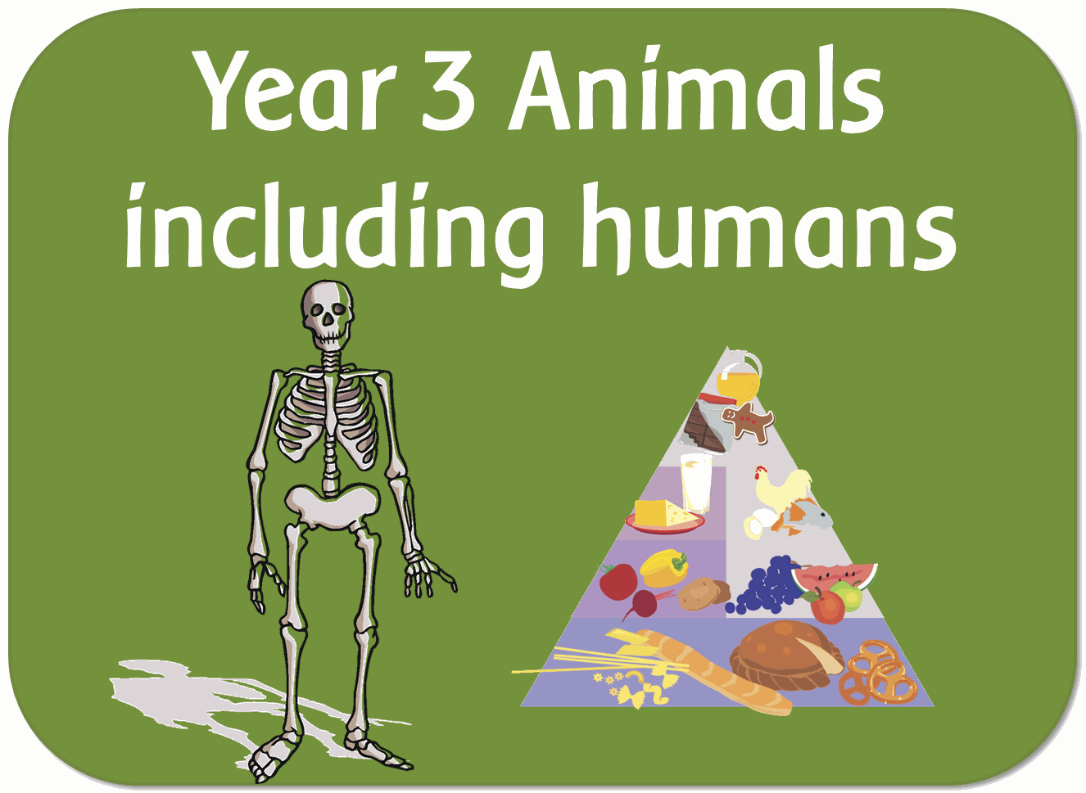
The Learning Journey:
(N.C. Objectives by week)
Can I state why animals need the right type of nutrients?
Can I plan a healthy meal?
Can I sort animals based on their skeletons?
Can I identify and name bones?
Can I identify and explain the three main functions of a skeleton?
Can I conduct an experiment about moving muscles?
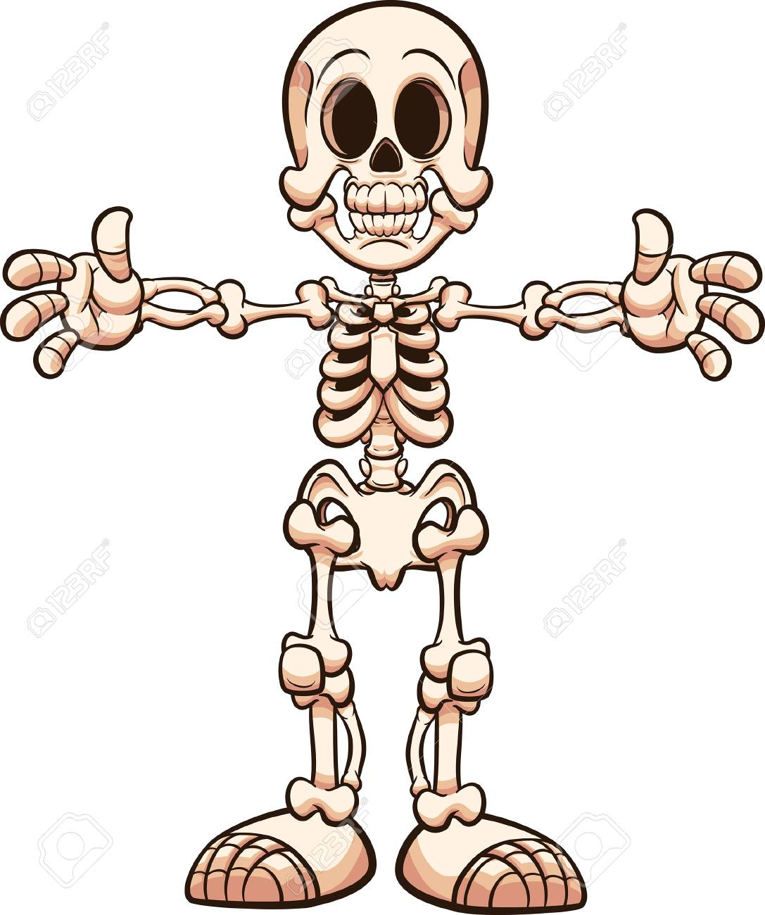
Knowledge outcomes:
Identify that animals, including humans, need the right types and amount of nutrition, and that they cannot make their own food; they get nutrition from what they eat
Identify that humans and some other animals have skeletons and muscles for support, protection and movement.
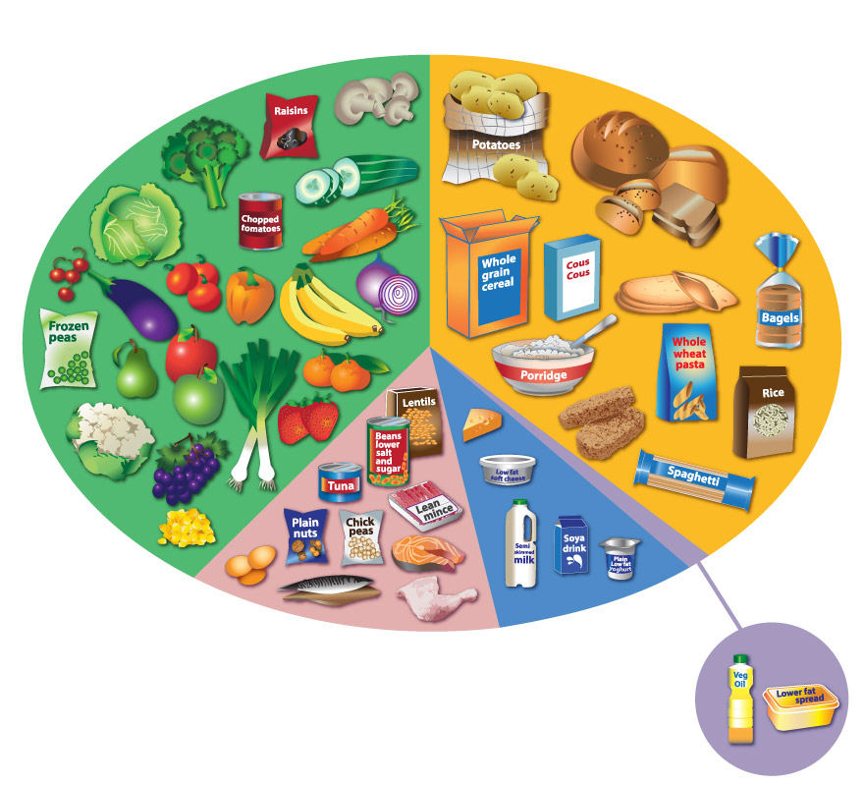
Animals Including Humans

