St Mary’s C of E Primary School, Writhlington
‘Inspiring Learning Together’
Scheme of Work + Knowlegde Organiser
Picture or illustration:
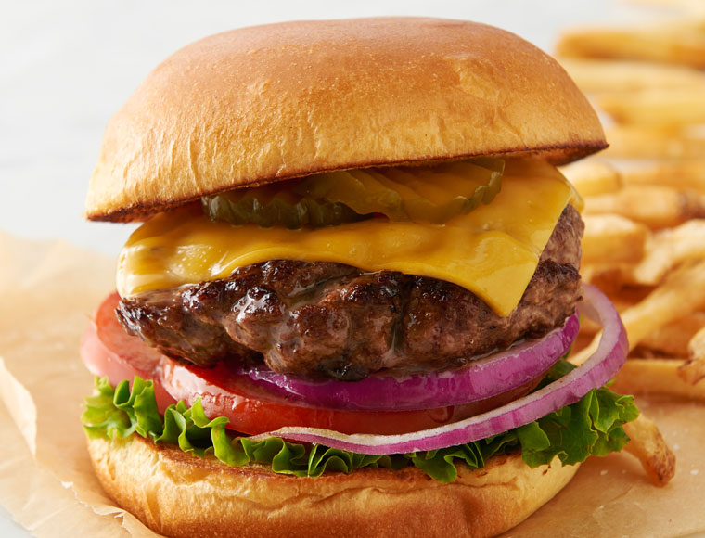

National Curriculum:

Wider Curriculum (Cooking, trips, outdoor):

Key Vocabulary:

The Learning Journey:
LQ: Can I explore different types of burgers and their nutrition facts
- Discuss and explore different types of burgers and look at the nutrition values of each one.
LQ: Can I make a burger patties?
- Create a class burger patty using a recipie.
LQ: Can I explore sauces and side dishes for burgers?
- Make different sauces and taste, discuss which would be best suited to a vegetarian, beef or turkey patty
LQ: Can I explore burger buns and their suitability?
- Children will taste and explore a selection of bread rolls recording their thoughts.
LQ: Are you able to plan and design a burger to make considering ingredients and flavors that may complement each other?
- Children will plan their own burgers in groups based on a diet preference.
LQ: Can you make a burger and evaluate the process?
- Children make their designed burgers, each group will taste and evaluate.
Burgers

