St Mary’s C of E Primary School, Writhlington
‘Inspiring Learning Together’
Scheme of Work + Knowlegde Organiser

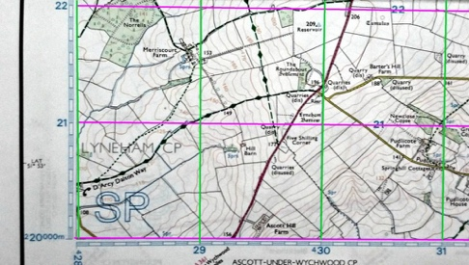
Wider Curriculum (Cooking, trips, outdoor):
Using the outdoor area to develop orienteering skills.
National Curriculums
Use the eight points of a compass, four and six-figure grid references, symbols and key (including the use of ordnance survey maps) to build their knowledge of the United Kingdom and the wider world.
Key Vocabulary:
Grid reference: a map reference indication a location
Scale: the ratio of distance on the map to the corresponding distance on the ground.
Contours: lines on a map which join up areas of the same height usually orange
Relief: the shape of the land

Picture or illustration:
The Learning Journey:
- Can I describe features on an ordnance survey map?
- Can I use the eight compass points to describe routes on a map?
- Can I use four or six-figure references to locate places on a map?
- Can I plan a journey using the eight compass points and four or six-figure grid reference?
- Can I describe how land use has changes over time?

Maps – Stargazers

