Year 3 Homework: Term 2
Our topic for this term is Natural Disasters. To help us with our learning, please complete at least one of these each week to be handed in on a Friday.
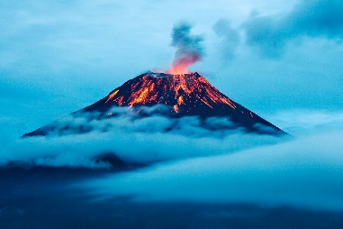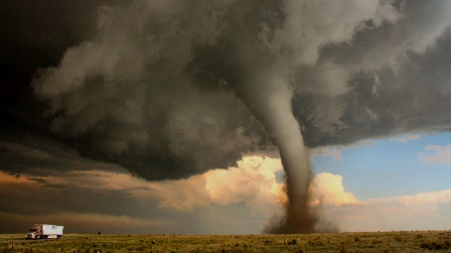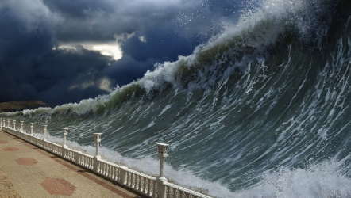

- Create a drawing, painting or model of a volcano.
- Write a poem based on hurricanes.
- Design a board game based on either volcanoes, earthquakes, tsunamis, tornadoes or hurricanes.
- Use a dictionary or the internet to find and write definitions for volcano, earthquake, tsunami, tornado and hurricane.
- Find out about the Ring of Fire. Make a fact sheet including some or all of the following: diagrams, pictures, facts and maps.
- Design a travel leaflet to encourage people to visit a volcano. Explain what they will see, be able to do and why they should visit.
- Research recent natural disasters that have been in the news and write sentences to display your findings.
- Research the positive and negatives of living in a storm prone area.
- Write a diary entry for the day a natural disaster struck in your town.
- Create a story called ‘The Earthquake Adventure’.
- Create a 3D model to represent the different layers of the earth. This could be done using a range of different materials.
- Draw and label an emergency kit full of items that might be needed after an earthquake.
- Use a world map to plot different natural disasters on. What type of disaster were they and when did they happen?

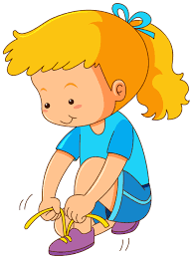
I successfully completed the half term challenge
I can tie my shoe laces!

Name:
Date:

HALF TERM
CHALLENGE!
Autumn Term One Challenge:
Learn to tie your shoe laces!
Children will be rewarded with a certificate and prize for completing this challenge. Good luck!

HALF TERM
CHALLENGE!

