St Mary’s C of E Primary School, Writhlington
‘Inspiring Learning Together’
Scheme of Work + Knowlegde Organiser
Picture or illustration: 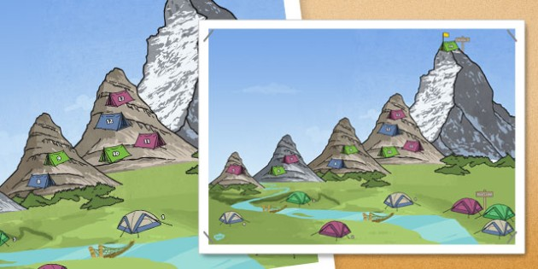

National Curriculum:
Human and physical geography
♣ describe and understand key aspects of:
♣ physical geography, including: climate zones, biomes and vegetation belts, rivers, mountains, volcanoes and earthquakes, and the water cycle
Wider Curriculum (Cooking, trips, outdoor):
N/A
Key Vocabulary:
Altitude – the height above sea level
Avalanche – a large amount of snow that quickly moves down a mountain or slope
Crust – the outmost layer of the Earth
Gorges – a narrow valley with steep walls, found between hills or mountains
Hypothermia – a serious condition when the body gets too cold and can’t warm itself up.
Lava – hot, liquid rock that flows from a volcano
Magma – hot liquid rock located deep below the earth’s surface
Summit – the highest point of a mountain
Tectonic plate – pieces of the Earth’s crust connected together.
Source – the beginning of a river sometimes known as its headwaters.
Tributary – a river or stream that feeds into another river, rather than ending in a lake,
Watershed – the area of land that drains into a specific river.
Floodplain – an (often low-lying) area of land which becomes covered in water when a river overflows.
Channel – the path a river takes it’s called its channel. A rivers course depends on the amount of water it holds, how long it has been flowing, and the types of rock that it flows over.
Riverbank – the land immediately along the river. The land is often fertile.
Confluence – the junction of two rivers.
Flow – the name given for the amount of water that a river holds. This can change through the year.

The Learning Journey:
- LQ: Can I use the index of an atlas to find mountains and find the height of a peak on a map?

- LQ: Can I locate key areas of higher ground in the UK and draw contour lines to show higher ground?

- LQ: Can I describe the key features of mountain ranges?

- LQ: Can I explain how different types of mountains are formed?

- LQ: Can I locate the key rivers of the world?

- LQ: Can I describe the key features of a river system?

- LQ: Can I describe the ways rivers are used and explain the impact of damming rivers?

Mountains and rivers

