St Mary’s C of E Primary School, Writhlington
‘Inspiring Learning Together’
Scheme of Work + Knowledge Organiser
National Curriculum Knowledge outcomes:

Design:
generate, develop, model and communicate their ideas through talking, drawing, templates, mock-ups and, where appropriate, information and communication technology

Make:
select from and use a range of tools and equipment to perform practical tasks [for example, cutting, shaping, joining and finishing]
Evaluate:
explore and evaluate a range of existing products
evaluate their ideas and products against design criteria
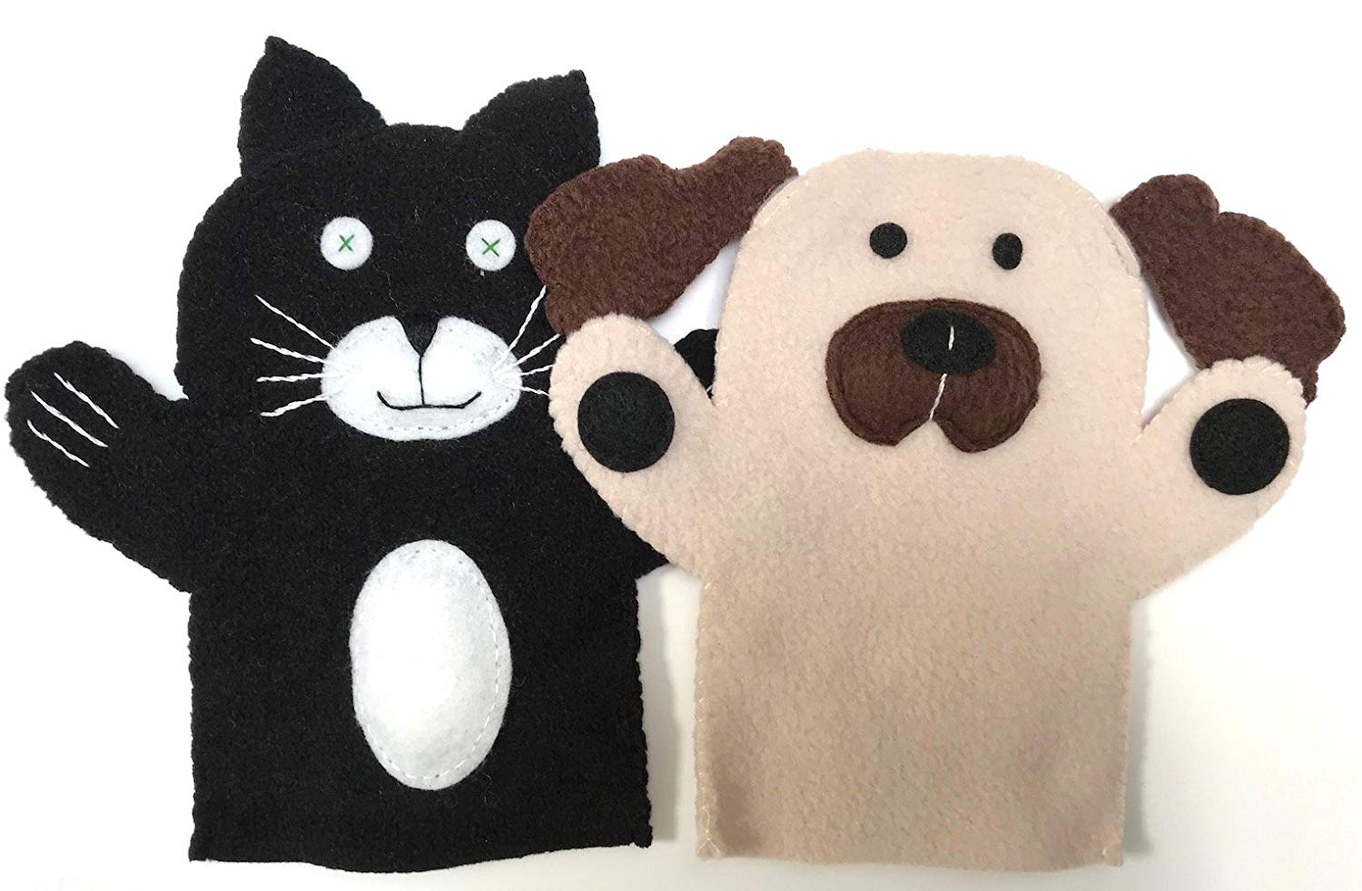
Wider Curriculum (Cooking, trips, outdoor):
Perform a puppet show.
The Learning Journey:
LQ: Do I know that there are different types of puppets? Do I know that puppets are made up of different parts? Can I make to make simple drawings and label parts?
LQ? Can I work with fabric to create a finger puppet?
LQ: Can I use basic sewing techniques? Can I to use a template to mark out identical pieces of fabric? Can I use simple vocabulary associated with the use of textiles?
LQ: Do I have ideas for my own designs can be developed by looking at a selection of puppets? Can I identify simple design criteria and then evaluate against design criteria?
LQ: Can I follow a design to make a puppet?
LQ: Can I evaluate my puppet?
Key Vocabulary:
Spelling | Definition/Sentence
puppet | A movable model of a person or animal that is typically moved by strings or hands
finger puppet | a small movable model placed on one finger
glove puppet | a movable model controlled when a hand is inserted
material | the substance of which a thing is made
running stitch | a sewing stitch made by passing the needle in and out repeatedly with short even stitches
over stitch | a stitch made for binding or finishing an edge
design | to prepare the preliminary sketch/plan for a work to be executed
evaluate | to judge or value the worth of something

DT: ‘Puppets’ – Year 1

