St Mary’s C of E Primary School, Writhlington
‘Inspiring Learning Together’
Scheme of Work + Knowlegde Organiser
Key Vocabulary:
Spelling | Definition/Sentence
Pentecost | The 50th day after Easter, celebrating the disciples receiving the Holy Spirit
Holy Spirit | The third person of the Trinity – God the Father, God the Son, God the Holy Spirit
Fruit of the Holy Spirit | The nine attributes of a person or community living in accord with the Holy Spirit

Knowledge outcomes:
Make clear links between the story of the Day of Pentecost and Christian belief about the Kingdom of God on Earth
Offer suggestions about what the description of Pentecost in Acts 2 might mean
Give examples of what Pentecost means to some Christians now
Make simple links between the description of the Day of Pentecost in Acts 2, the Holy Spirit and the Kingdom of God, and how Christians live their whole lives and in their church communities
Make links between ideas about the Kingdom of God explored in the Bible and what people believe about following God in the world today, expressing some of their own ideas
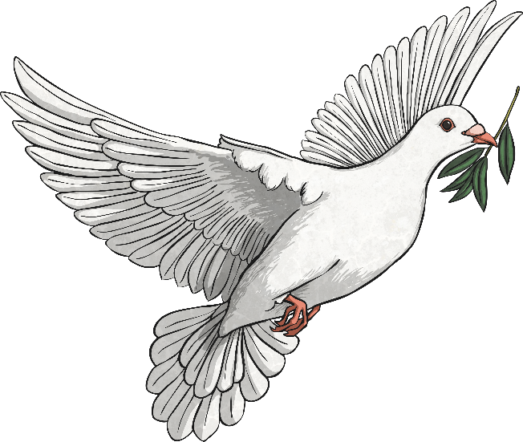
Wider Curriculum (Cooking, trips, outdoor):
The Learning Journey:
What is the Pentecost?
Children will hear the story of Pentecost and look at different artwork representing the story.
What is the Holy Spirit and why is it important to Christians?
Children will link a range of different items to the story of Pentecost. Children will discuss the Holy Spirit.
Why is the Pentecost important to Christians?
Children will think about life if the Pentecost didn’t happen. They will think about who they turn to when they are worried and consider who Christians turn to.
What is the body of Christ and how do Christians embrace it?
Children will discuss the importance of the ‘body’ and consider different scenarios, offering suggestions as to whether they would act as part of the body of independently.
Why is the fruit of the Spirit important and what impact has it has on our lives?
Children will learn about the 9 fruits which make up the fruit of the Spirit, discussing when they have been examples of these in society.
Kingdom of God – When Jesus left, what was the impact of Pentecost?

