St Mary’s C of E Primary School, Writhlington
‘Inspiring Learning Together’
Scheme of Work + Knowlegde Organiser

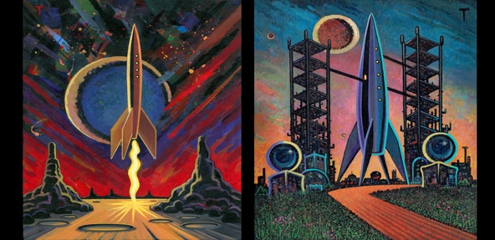
Key Vocabulary:
Definition/Sentence
Abstract: Abstract art is art that does not attempt to represent an accurate depiction of a visual reality but instead use shapes, colours, forms and gestural marks to achieve its effect
Portrait: is a painting or photograph of a person, in which the face is predominant
Landscape: is a painting or photograph of an area of land, water and space
Foreground: the part of a view that is nearest to the observer
Background: the part of view that is furthest from the observer and forms a setting for the main features.

The Learning Journey:
- Can I recall facts about Peter Thorpe and his style of art?
- Children will be introduced to peter Thorpe and his art, they will discuss and learn terminology about his style of art.
- Can I explore abstract art as a way of creating an effective background?
- Children will recap their understanding of abstract, using features of Peter Thorpe’s backgrounds to create one of their own.
- Can I recreate one of peter Thorpe’s paintings that will inspire my own final piece?
- Children will pick one of Peter Thorpe’s paintings to recreate allowing them to explore and develop their painting skills.
- Can I design my own space artwork with an abstract background inspired by Peter Thorpe?
- Can I create a final piece of art demonstrating my painting skills?

Wider Curriculum (Cooking, trips, outdoor):
Planetarium experience
National Curriculum:
Pupils should be taught:
-to create sketch books to record their observations and use them to review and revisit ideas.
- to improve their mastery of art and design techniques, including drawing, painting and sculpture with a range of materials (Paint).
- about great artists, architects and designers in history.
Picture or illustration:
Topic Title/Subject

