St Mary’s C of E Primary School, Writhlington
‘Inspiring Learning Together’
Scheme of Work + Knowlegde Organiser

Oracy:
Stem sentences within each lesson to support and aid predictions, explanations and conclusions.
Presentation of findings to class.
Key Vocabulary:
Spelling | Definition/Sentence
buoyancy | a force on an object making that object rise or move upward
weight | the measure of the force of gravity on an object
up thrust | the upward force that a liquid exerts on a body floating in it
surface area | total exposed area inside a given boundary
fair test | a test which controls all but one variable when attempting to answer a scientific question
prediction | say or estimate what will happen in the future

Working Scientifically:
Lesson 1: Set up simple practical enquiries/comparative tests, record findings in tables.
Lesson 2: Making careful observations, recording findings and drawing conclusions.
Lesson 3: Set up simple practical enquiry, record results using written evaluations and conclusions.
Lesson 4: Comparative testing, recording results via a bar graph and create conclusions.
The Learning Journey:
Why do some objects float, and others sink?
Children will investigate the buoyancy of different objects.
Can I measure my heartrate?
Children will measure their heart rate and learn how to present their findings in different ways.
Can you drop an egg without breaking it?
Children will experiment wrapping eggs in different materials in order to investigate whether the egg will break.
Which liquids melt the fastest?
Children will predict and experiment which liquids will melt the fastest.
Knowledge outcomes:
Ask questions and answer using different scientific enquiries
Complete practical enquiries, comparative and fair tests
Make observations using a range of equipment
Gather and present data in a range of different ways
Report on findings from enquiries
Draw simple conclusions, identifying differences and similarities
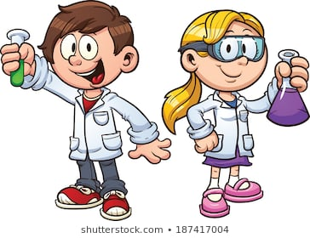

We Are Scientists!

