How much home learning should my child be doing each day?
The DfE says that home learning doesn’t have to mirror the patterns of the school day. You’re not required to:
- have a timetable
- have set hours during which education will take place
- observe school hours, days or terms
Try to spend some time on Literacy and Maths activities each day, as well as Reading. Little and often is the key, rather than a long period of time.

Children also need to be active. The current sunny weather is the perfect opportunity to play outside in the garden. Simply playing with a ball will develop children’s throwing and catching skills, while simple games will promote teamwork and healthy competition. Don’t forget that you may also go out of your house for a walk, run or bike ride once a day, in your family group. Please do remember to keep 2 metres away from anyone else.
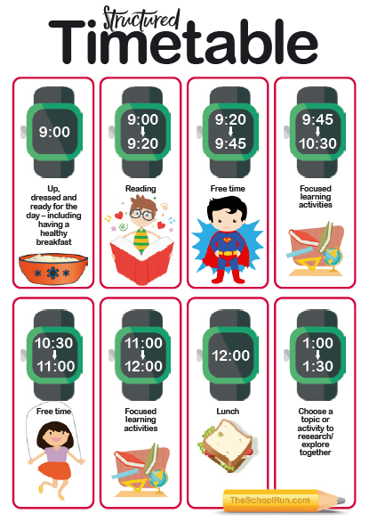
Art and craft activities, cooking, playing music and gardening are all valuable learning opportunities too. Our next Science topic in Year 2 is plants, so why not plant some seeds and observe how they grow? Also look at how other plants are growing and see if your child can name the different parts. Children often don't realise they're learning, while having fun too!

Try to keep to a routine each day, so children know what to expect and what your expectations are.

This timetable is a really useful guide and child-friendly too!

The following link will take you to theschoolrun.com where you can download the timetable for free and read further advice on how to get the best out of home learning.

https://www.theschoolrun.com/home-learning-timetables-for-coronavirus-school-closures

