St Mary’s C of E Primary School, Writhlington
‘Inspiring Learning Together’
Scheme of Work + Knowlegde Organise
Picture or illustration: 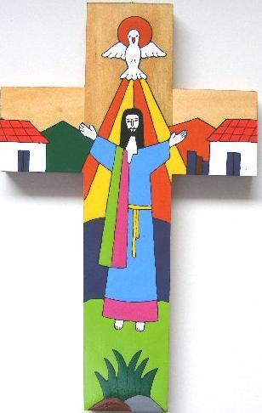
AMV:
AT1: express religious beliefs (ideas, feelings, etc) in a range of styles and words used by believers and suggest what they mean.

AT2: Ask questions about who we are and where we belong, and suggest answers which refer to people who have inspired and influenced myself and others, such as the Maryknoll Sisters.

Key Vocabulary:
Symbolism: the use of symbols to represent ideas of qualities
Saviour: a person who saves someone or something from danger or difficulty
Christianity a religion based on the life and teachers of jesus
Life journey: how we live our life to learn lessons deal with hardships, heartaches, joys, celebrations and special moments that will ultimately lead us to our destination.
Humanity: the quality of being humane
Respectful: feeling or showing respect (due regard for the feelings, wishes, or rights of others)
Crucifixion: a method of punishment where the victim is nailed to a cross (used by the Romans on Jesus)

The Learning Journey:
LQ: Can I consider how people express information, ideas, feelings and beliefs in a variety of ways?
- Children will learn that the cross is a sign of hope as well as other representations of Christian beliefs.
LQ: Can I reflect on the value of being part of a community??
- Children will learn about aspects of El Salvador’s history and the influence and activities of some religious groups on behalf of the poor and refugees.
LQ: Can I reflect on what fives meaning to their lives and consider why God is important?
- Reflect upon the underlying meaning of different forms of expression on the crosses: signs and symbols, artistic expression, universal symbols, the use of vibrant colour.
LQ: Can I reflect on themes of hope and reconciliation?
- Children will create a short poem encapsulating what is means to be human.
How do people express their beliefs and identity?

