St Mary’s C of E Primary School, Writhlington
‘Inspiring Learning Together’
Scheme of Work + Knowlegde Organiser
Key Vocabulary:
Spelling | Definition/Sentence
The Arctic | A polar region located at the northernmost part of the earth
North Pole | The northern end of the earth’s axis - there is no land here.
Hemisphere | A half of a sphere
Equator | The imaginary circle around the earth and divides it into two equal parts
Seasons | Four different times during the year with different types of weather
Iceberg | A large mass of ice that has broken away from the glacier and is floating in the sea
Landscape | An area of land as one can see it – landforms/flora/fauna/human elements
Inuit | North American Arctic people – one person is an Inuk
Hunters | People who pursue and kill animals
Igloo | A dome-shaped shelter made from blocks of snow placed on top of each other
Adaptations | A special skill – physical or behavioural - which helps an animal survive
Polar Bear | World’s largest carnivore that lives on land - it is a mammal

Knowledge outcomes:
All children will:
Know where the Arctic/North Pole is.
Describe what the weather is like.
Be able to name some of the animals that live there.
Most children will:
Understand adaptation for some animals.
Describe the landscape.
Some children will:
Make comparisons between seasonal changes in UK and the Arctic.
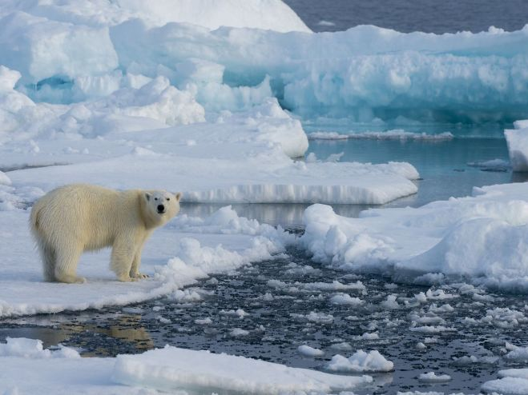
The Learning Journey:
Where do Polar Bears live?
Where is the Arctic?
What is the Arctic landscape like?

What is the weather like in the Arctic?
Are seasons there like ours?

What other animals live in the Arctic?

What is special about Arctic animals to enable them to live in that environment?

What are the Northern Lights?

Rainbow Bear: The Arctic - Geography

