St Mary’s C of E Primary School, Writhlington
‘Inspiring Learning Together’
Scheme of Work + Knowledge Organiser
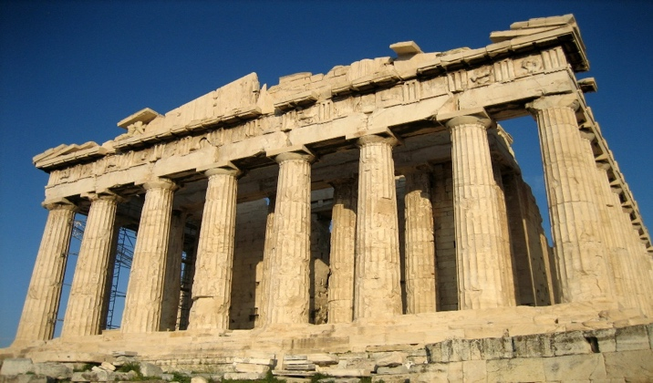
Pupils can organise information purposefully when responding to or asking questions
The Learning Journey:
- Can I build on prior knowledge and locate Greece on a map?
- Can I identify Ancient Greece on the timeline?
- Can I compare ancient and modern democracy?
- Can I explain what a city state is?
- Can I infer information about Greek wars and warfare from illustrations and maps?
- Can I explain the events of a key battle in Ancient Greece?
- Can I explain the role of the theatre in the way of life of the Greeks?
- Can I make links between the Greek alphabet and the current alphabet?
- Can I make inferences and deductions about Greek life using a range of Greek pottery?
- Can I create a vase in the style of the Ancient Greeks?
- Can I explain the religious beliefs of the Ancient Greeks?

Wider Curriculum (Cooking, trips, outdoor):
Making Greek masks and clay pots
- National Curriculum Knowledge outcomes:
Pupils have a wide ranging knowledge about historical events, from local history to world history
- Pupils have a deep understanding of how our knowledge of history is developed, identifying how a range of sources build up our knowledge and understanding
- Pupils can organise information purposefully when responding to or asking questions
- Pupils have a secure knowledge of chronology, accurately placing a range of historical events from around the world on a timeline
- Pupils can draw their own timeline, deciding on accurate intervals and adding to it as they learn about new periods of history

Key Vocabulary:
Spelling | Definition/Sentence
Acropolis | An acropolis is a fortified citadel within a larger city. It is usually located on top of a hill and at the centre of the city
Assembly | In Athens the Assembly consisted of the group of citizens who showed up to vote
Democracy | A form of government where citizens have a say in how they are ruled including choosing their leaders and deciding on laws
empire | a number of individual nations that are all controlled by the government or ruler of one particular country
Olympics | An athletic event held by the Ancient Greeks every four years
Titans | The Titans were the first Greek gods
Mount Olympus | Mount Olympus is the highest mountain in Greece. It was believed in Ancient Greek times that when things needed to be decided in the mystical world, the 12 main Gods would gather at Mount Olympus, and that many lived there.
mythology | a group of myths, especially all the myths from a particular country, religion, or culture.
deities | Gods or goddesses

Picture or illustration:
Topic Ancient Greece

