St Mary’s C of E Primary School, Writhlington
‘Inspiring Learning Together’
Scheme of Work + Knowlegde Organiser
Key Vocabulary:
Spelling | Definition/Sentence
igneous | rock formed by the cooling of magma
sedimentary | rock formed by the accumulation of small particles in a body of water
metamorphic | rock formed from other rocks that are changes because of heat or pressure
permeable | allowing liquid to pass through
impermeable | does not allow liquid to pass through
fossil | any preserved remains, impression or trace of any once-living thing
top soil | the upper, most outer layer of soil
sub soil | the soil lying immediately under top soil
base rock | the solid rock underneath soil

Rock On!
Wider Curriculum (Cooking, trips, outdoor):
Make your own compost, make your own fossils, exploring the outside for worms for our compost!
Learning objectives:
Compare and group together different kinds of rocks on the basis of their appearance and simple physical properties
Describe in simple terms how fossils are formed when things that have lived are trapped within rock

Recognise that soils are made from rocks and organic matter

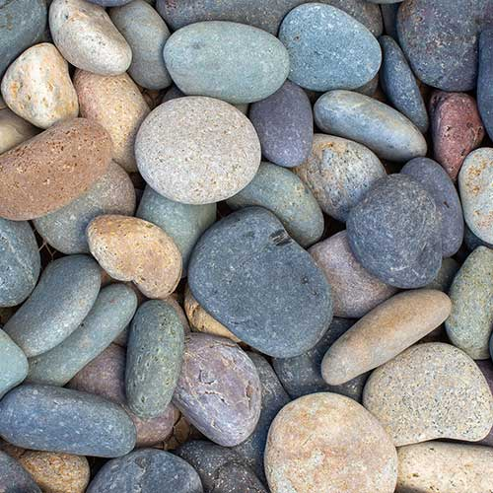n:
The Learning Journey:
Can I compare different types of rocks?
Children look at the three rock types, igneous, sedimentary and metamorphic. Using sweets, children to have a go at making each different type of rock.
Can I group rocks based on their properties?
Children to conduct an experiment looking at rock permeability, durability and density.
Can I explain how fossils are formed?
Children to create their own fossils using salt dough and classroom objects.
Can I explain Mary Anning’s contribution to paleontology?
Children to use the iPads to research Mary Anning’s life, creating a fact file about her scientific work.
Can I explain how soil is formed?
Children to inspect soil to see what they can find. Children to then make their own ‘soil’ – rocky road!
Can I investigate soil permeability?
Children to test different types of soil to determine its permeability and then write up the finding and results from their experiment.

