St Mary’s C of E Primary School, Writhlington
‘Inspiring Learning Together’
Scheme of Work + Knowlegde Organiser
Knowledge outcomes:
All children will:
- know that Radstock was a thriving mining community
Most children will:
- understand what it was like to be a miner
Some children will:
- draw comparisons between Radstock now and then

Key Vocabulary:
Spelling | Definition/Sentence
Radstock | a town in Somerset – our most local town/community
Writhlington | a suburb (outlying area) of Radstock – where our school is
mine | a deep hole made in the earth to get to useful minerals
mining | The act of digging up coal or other minerals
miner | a person whose job is to dig coal or other minerals from a mine
child labour | full-time employment of a child under a minimum age
coal | a hard black mineral that is found in the earth and used for fuel
colliery | a coal mine including all the buildings and equipment
Queen Victoria | the Queen of Great Britain from 1837 - 1901
Victorian | Relating to the time of the reign of Queen Victoria

Class 1 – What’s Under My Feet?
Picture or illustration: 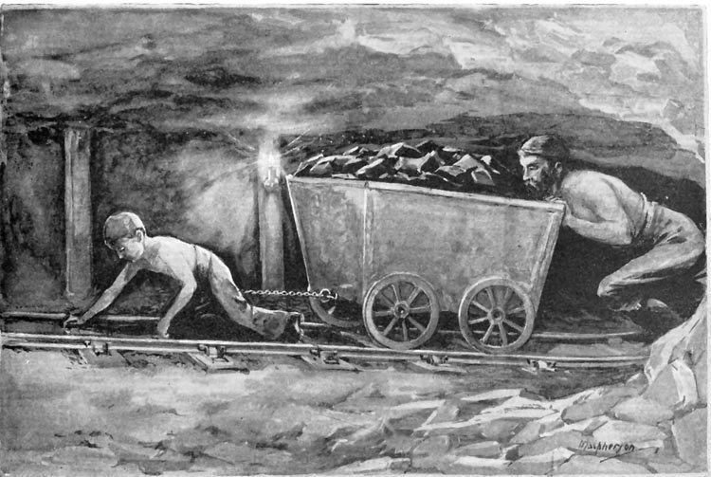 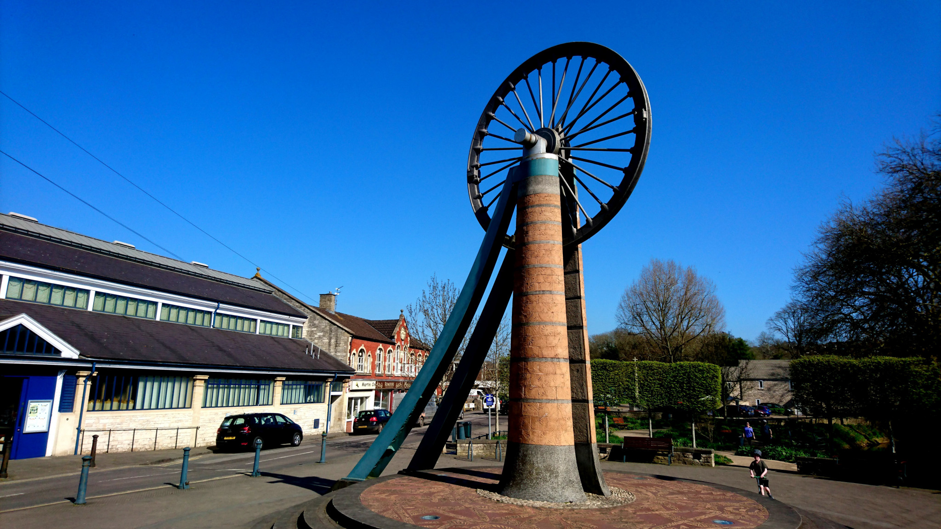
Wider Curriculum (Cooking, trips, outdoor):
Local walks; visit to Radstock Museum; link to Art: LS Lowri
The Learning Journey:
Pupils should be taught: significant historical events, people and places in their own locality.
What could you see in Radstock 150 years ago? (buildings, streets, people)
What job would you do in Radstock in the past? (children)
Why was mining so important to Radstock people?
What did a coalminer do?
What questions can we ask about the past?
What did Miners eat?
Can I talk and write about what Writhlington and Radstock were like in the past?

