

**Year 3**

**Spring Term 2**

**Key Instant Recall Facts**

**Reception – Autumn Term 2**

I know the multiplication and division facts

for the 8 times tables

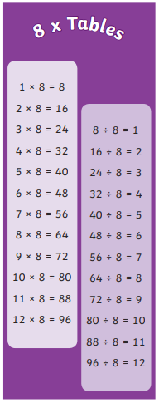

**Top tips for learning at home**

When learning key recall facts it is important to do so little but often. You could practise these KIRFs while walking to school or during a car journey. You don’t need to practice them all at once: perhaps you could have a fact of the day. If you would like more ideas, please speak to your child’s teacher.

Children should be able to answer these questions in any order, including missing number questions e.g. 8 × ⃝ = 16 or ⃝ ÷ 8 = 7.

**Use practical resources** – You could use many household objects to count in groups of 8. Or share into 8 groups / group objects in 8s to practice dividing.

**Songs and Chants –** You can buy Times Tables CDs or find multiplication songs and chants online. If your child creates their own song, this can make the times tables even more memorable.

**Double your fours –** Multiplying a number by 8 is the same as multiply by 4 and then doubling the answer. 8 × 4 = 32 and double 32 is 64, so 8 × 8 = 64.

**Five six seven eight –** fifty-six is seven times eight (56 = 7 × 8).

**Play games** – You can play games online at [topmarks.co.uk/times-tables/coconut-multiples](https://www.topmarks.co.uk/times-tables/coconut-multiples) or [timestables.co.uk/](https://www.timestables.co.uk/)

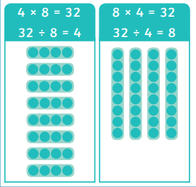



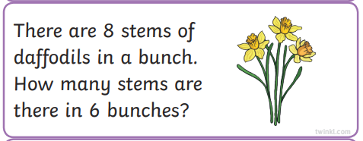

**Key Vocabulary**

equal groups lots of

repeated addition arrays

multiplication multiply

times multiplied by

share group

divide divided by