|  |
| --- |
| **Class 1 Newsletter Term 1 – September 2020** |

**WELCOME TO CLASS ONE!**

Welcome back to all of our children and families after the summer holidays. Coming back to a new class after summer – and for some children quite an extended break – can be daunting for some but I want to start by saying how impressed we have been with how well your children have left you at the gate and settled into Class 1. Thank you for assisting us with that.

From Monday to Thursday, Mrs Roberts will be teaching the class. On Fridays, Miss Hamblin will be the class teacher. We are lucky to be supported by Mrs Lock and Mrs Appleby who will be there all week!

We are really looking forward to the new term, with lots of exciting and interesting things for the children to do. We hope that our newsletter will give you all the information you need for the term ahead, but if you have any questions please do not hesitate to grab us at the start or end of the day.

**What we are learning**

Our *History* topic this term is *London’s Burning* which is all about The Great Fire of London, focusing on History and Personal Safety. Early on in the term we are hoping to have a visit from the local Fire Service to talk to the children about their work in the community.

Our topic will continue throughout the curriculum. In *Design and Technology* we will be investigating fire engines and using what we find out to design and make our own.

We are going to be continuing to develop our understanding of the number system in maths and for much of this term we will be focussing on Number - Place Value. One of our initial objectives is counting to – and back from – 100 (and beyond). We will work a lot on this in class but it would be great if you could practise this at home too.

[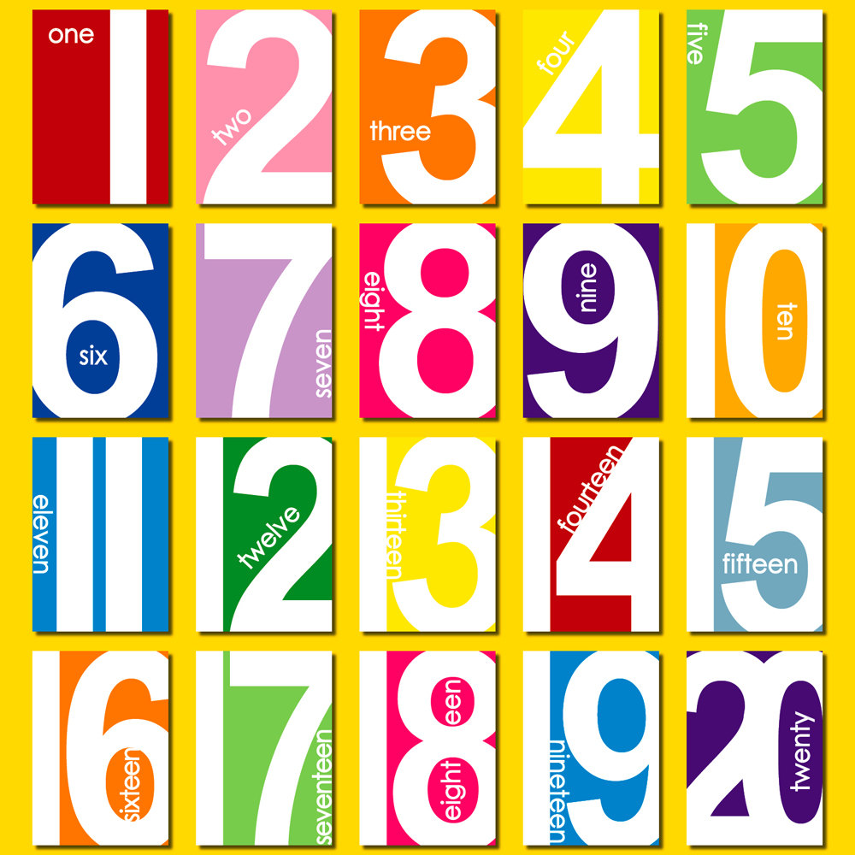](http://www.google.co.uk/url?sa=i&rct=j&q=&esrc=s&source=images&cd=&cad=rja&uact=8&ved=0ahUKEwjplbDM44fPAhVjC8AKHcFjAW0QjRwIBw&url=http://www.clipartkid.com/clip-art-numbers-1-20-cliparts/&psig=AFQjCNFlOzXcNxb8TuYROQB-1f87iUutQQ&ust=1473699218450145)

For *Literacy*, we will be starting off with the very familiar *We’re Going on a Bear Hunt* which the children will learn to recite confidently before starting to write simple sentences. In the second half of the term we will be writing about the Great Fire of London as our non-fiction unit. For poetry, we are going to learn by heart some poems. Ask your children to perform them for you at home!

In *Science* we will be learning about *Seasonal Changes* - when each season is; what the characteristics of each is; how the weather changes and the effect it has on us and other animals. We will find out why the sun changes its position in the sky and when we’re on the ‘dark-side’!

Our Computing sessions this term will cover many aspects of *ICT* including the ways in which children use technology in their lives and its benefits and elements of e-safety.

We will be looking at the story of Creation for RE where the children will recognise that ‘Creation’ is the beginning of the ‘big story’ of the Bible. They will be able to retell the story of creation from Genesis 1:1–2.3 simply and say what the story tells Christians about God, Creation and the world.

**Reading**

Your child will be bringing home two reading books to read with you at home. The day for this will depend on which day your child is reading with the Teacher or TA. One of the books they will bring home will be Phonics based and intrinsically linked to your child’s level and requirements. The other book will also be of an appropriate level but will be chosen by your child. Please try to listen to your child read as often as possible and talk about the stories they have read. Children like repetition and it is therefore helpful to your child to reread their reading book several times before it is changed – we will be keen to ensure your child is secure at a book/level before moving them to the next. As they become more familiar with the text and story, they will gain more confidence in their reading and be able to talk about what has happened and recall elements of the text.

*Please bear with us over the next couple of weeks as we assess where the children are and select an appropriate book. If in the short term the book seems too easy, it may just be a chance for us to recap on some valuable phonics phases.*

We also ask that you write a comment in or simply sign the reading record, so that we know how your child has read the book and that it needs to be changed. Reading books will be changed once a week unless the book has not been read.

**Whole Class and Guided Reading**

Reading within Class 1 is done during **Whole class** and **Guided Reading** sessions. During Guided Reading the class is divided into four groups, with each group at around the same level in their reading. The teacher and TA reads with each group once a week on a rota basis. The rest of the class engage in other reading and spelling activities. This is an opportunity for us to give individual help and to assess each child’s progress and needs. It has been proven that this method of listening to children read is far more effective in developing their reading skills than listening to each child individually. However, where a child is making slow progress with their reading, one to one support will be given regularly throughout the week.

We also make sure we have time for a story every day in class. Reading and listening to stories is fundamental to children’s learning and it’s fun!

|  |
| --- |
|  |
|  |

PE

PE will normally be every Monday and Wednesday. At St Mary’s, our PE kit should include a white t-shirt, black shorts/joggers and daps for outdoor activities. At the moment, we would be grateful if children come into school already dressed in their kit on these PE days and trainers may be more appropriate for outside play.

Please can you still make sure all items of clothing are named? Children are always misplacing their jumpers or cardigans and once named they are so easy to return to their rightful owner! Although it seems children have a special skill of being able to ‘smell’ to see if a jumper belongs to them! Thank you.

Water Bottles and Snacks

It is very important that the children have fresh water each day and at the moment whilst we have to not allow the use of the water fountain, it is even more important for them to bring their own bottles in. Please can you ensure your child has one in school, with their name on, which they will need to take home each evening to wash?

Each day the children will continue to have a piece of fruit for their snack, as part of the government’s School Fruit and Vegetable Scheme. This includes a variety of fruit and vegetables such as bananas, apples, tangerines, tomatoes, carrots, pears and dried fruit such as raisins and mango.