St Mary’s C of E Primary School, Writhlington
‘Inspiring Learning Together’
Scheme of Work + Knowledge Organiser
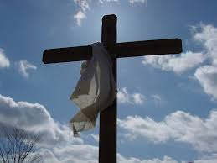
Wider Curriculum:
Visit to the local church and questioning the reverend.
The Learning Journey:
Can I reflect upon qualities needed in different situations?
Making real life connections of people who ‘save the day’.
Can I find and reflect upon bible verses?

Can I use the bible to think about what the people of God were expecting?

Can I examine written evidence?

Can I can understand the impact of Christmas to Christians?
Looking at the meaning of Christmas.
Can I reflect upon the world’s view of a messenger?
Summary of the unit.
National Curriculum knowledge outcomes:

- Describe and make connections between different features of the religions and worldviews, discovering more about celebrations, worship, pilgrimages and rituals.
- Explore and describe a range of beliefs, symbols and actions so they can understand different ways of life and ways of expressing meaning.
- Understand the challenges of commitment to a faith community, suggesting why belonging to a community might be valuable.

Key Vocabulary:
Spelling | Definition/Sentence
Messiah | Means ‘the anointed one’ who will save the world
Trinity | A word used to describe the 3 different persons who are God: The father, the son and the Holy Spirit.
Descendant | Someone related to someone who lived at an earlier time.
Prophecies | Something foretold – a prediction of what will happen in the future
Incarnation | Means ‘in the flesh’. Jesus is considered to be God in the flesh.

RE – Was Jesus the Messiah?

