

**Year 4**

**Spring Term 2**

**Key Instant Recall Facts**

**Reception – Autumn Term 2**

I can find fractions of amounts.

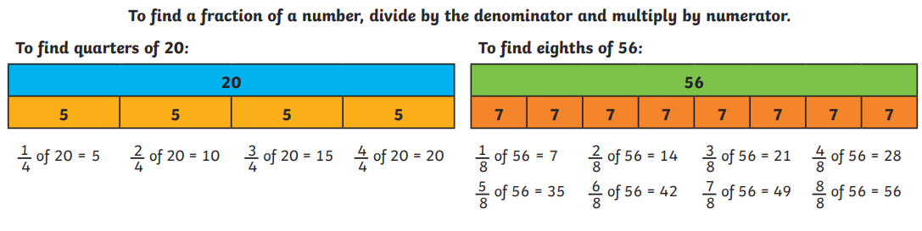

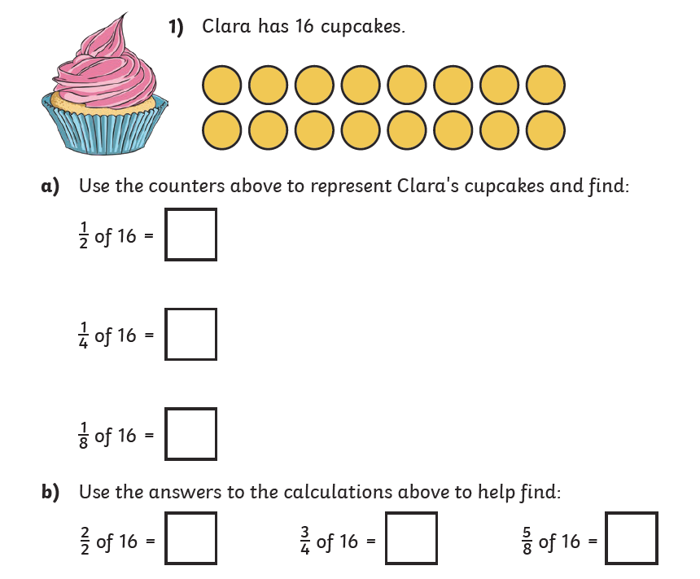

**Top tips for learning at home**

When learning key recall facts it is important to do so little but often. You could practise these KIRFs while walking to school or during a car journey. You don’t need to practice them all at once: perhaps you could have a fact of the day. If you would like more ideas, please speak to your child’s teacher.

**Use practical resources** – You could use items around the home for find fractions of different quantities. Raisins, sweets or pasta shapes are good for this.

**Lego** - Lego bricks are fantastic for working with fractions:

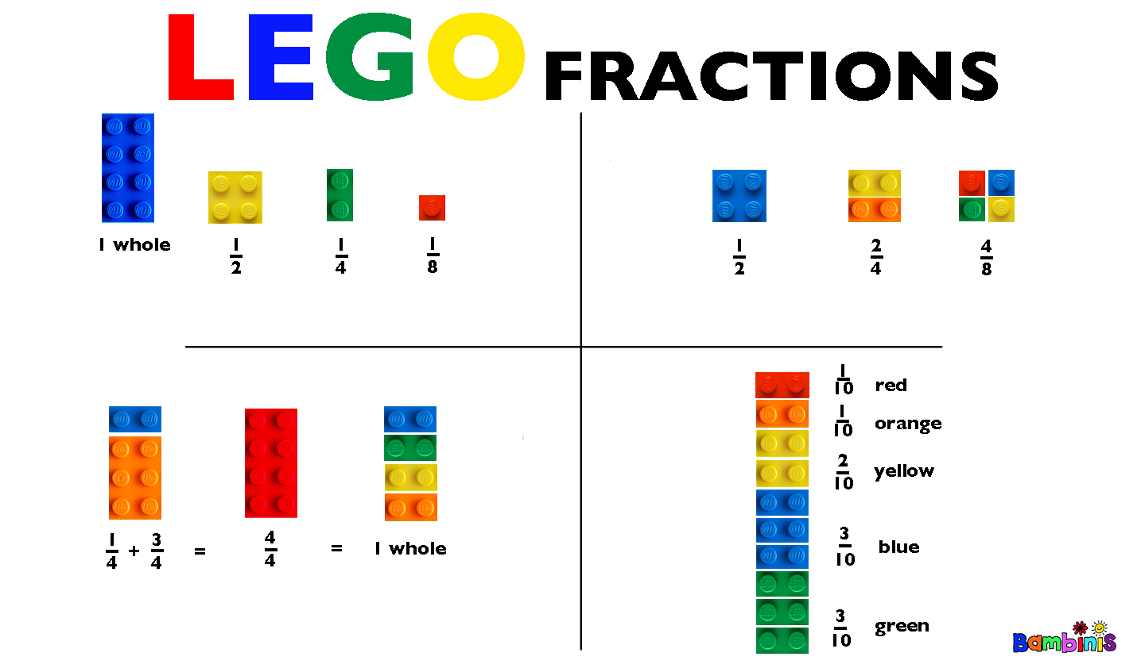

**Key Vocabulary**

fraction

numerator

denominator

divide

multiply

quantities

whole

halves

thirds

quarters

fifths

sixths

sevenths

eighths

ninths

tenths

elevenths

twelfths