St Mary’s C of E Primary School, Writhlington
‘Inspiring Learning Together’
Scheme of Work + Knowlegde Organiser
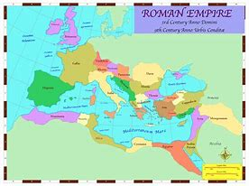
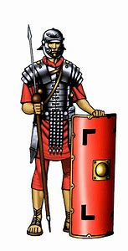
The Learning Journey:
How did the Roman Empire emerge and expand?
Children will place key dates on a timeline and discuss the expansion of the Roman Empire, highlighting this on a map.
How did the power of the Roman Army help the Roman Empire?
Children will learn about what life was like in the Roman army and create a job advertisement for a traditional Roman solider.

How did Britain become part of the Roman Empire?
Children will consider the events in the lead up to the Romans invade of Britain.
Who was Boudica?
Children will be introduced to different historical sources to learn the story of Boudica’s rebellion. They will make a comic strip and learn a song about Boudica.
What did the Romans build after they settled in Britain?
Children will look at different buildings and structures, learning new vocabulary, before researching Roman roads and aqueducts.
What were houses like in Roman Britain?
Children will find out about the types of houses different Roman people used to live in, before creating their own advert to promote one type of Roman house.
What was the hierarchy of Roman society?
Children will be treated unfairly to find out what life was really like as a Roman slave, before writing a letter home asking to be saved.

Wider Curriculum (Cooking, trips, outdoor):
Roman Sports Day, Creating Roman mosaics in Art
Key Vocabulary:
Spelling | Definition/Sentence
AD | ‘Anno Domino’ – the time after the birth of Jesus Christ
BC | ‘Before Christ’ - the time before the birth of Jesus Christ
conquer | to take control of a place by fighting
emperor | a person who rules an empire
gladiator | a man trained to fight in an arena with weapons
villa | a large luxury home, usually built for wealthy people to live in
legacy | something that is handed down from one period of time to another period of time
legion | the main unit of the Roman army
manumission | the act of a slave master freeing a slave
mosaic | a picture made from tiles
slave | a person who is the legal property of another and is forced to obey them

Knowledge outcomes:
Julius Caesar’s attempted invasion in 55-54 BC
The Roman Empire by AD 42 and the power of its army
Successful invasion by Claudius and conquest, including Hadrian’s Wall
British resistance, for example, Boudica
‘Romanisation’ of Britain: sites such as Caerwent and the impact of technology, culture and beliefs, including early Christianity
Picture or illustration:

The Rotten Romans!

