

**Term 1**

**2018**

**Class 1**

**Newsletter**

**WELCOME TO CLASS ONE!**

Welcome back to all of our children and families after the summer break. We are really looking forward to the new term, with lots of exciting and interesting things for the children to do. We hope that our newsletter will give you all the information you need for the term ahead, but if you have any questions please do not hesitate to come and see us. There will also be a Parents Meeting where you can come and meet the teachers on Wednesday 19th September, straight after school in Class 1.

**Dates for this term**

th October – Harvest Celebration

th October – Parent’s Evening

October – End of Term 1

**What we are learning**

Our topic this term is ‘The Great Fire of London’, focusing on History and Personal Safety. Early on in the term we are hoping to have a visit from the local Fire Service to talk to the children about their work in the community.

Our topic will continue throughout the curriculum. In Design and Technology we will be investigating fire engines and using what we find out to design and make our own.

We are going to be continuing to develop our understanding of the number system in maths before moving on to exploring and comparing 2-D and 3-D shapes.

In Science we will be learning about the Seasons, how the weather changes and the effect it has on us and other animals. We will find out why the sun changes its position in the sky and when we’re on the ‘dark-side’!

Our Computing sessions this term will cover many aspects of ICT, including the ways in which children use technology in their lives and its benefits, elements of e-safety, and using some programs related to Toys.

[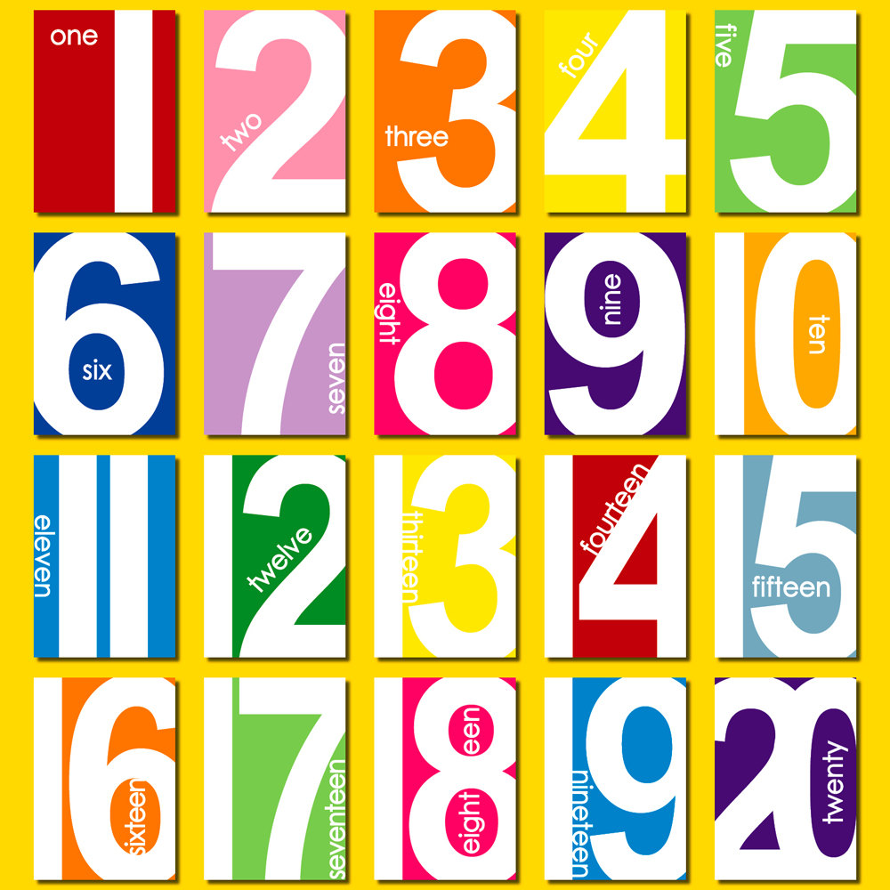](http://www.google.co.uk/url?sa=i&rct=j&q=&esrc=s&source=images&cd=&cad=rja&uact=8&ved=0ahUKEwjplbDM44fPAhVjC8AKHcFjAW0QjRwIBw&url=http://www.clipartkid.com/clip-art-numbers-1-20-cliparts/&psig=AFQjCNFlOzXcNxb8TuYROQB-1f87iUutQQ&ust=1473699218450145)

**Useful Information**

**PE**

In Class 2 PE will normally be every Monday and Friday. However, please make sure that your children have their PE kit in school at all times as there may be other opportunities for children to do physical activities throughout the week. Some of these may well be outside. At St Mary’s our PE kit should include a white t-shirt, black shorts and daps for outdoor activities.

**Please can you make sure all items of clothing are named.**

Children are always misplacing their jumpers or cardigans and once named they are so easy to return to their rightful owner!

**Homework**

Over the next few weeks we will be introducing phonics homework folders for each child, with their weekly homework stuck inside. Please encourage your child to complete their homework each week, as it consolidates the phonics work we have done in school and supports their learning. The focus of homework in Class 2 will be phonics and keyword practice. Homework will be sent home on a Thursday, with the expectation that it is completed and returned to school the following Wednesday. We will soon be having a Phonics meeting in order for you to see what exactly the children will be learning. We will let you know when the date for this will be.

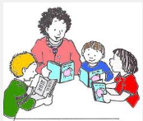

…and finally

It is very encouraging to see many parents saying goodbye to their children at the gate and allowing them to come in independently. The children benefit greatly from this and it means that they can settle much more quickly and quietly and become more independent.

As ever, if you have any worries or questions relating to your child please do not hesitate to catch us after school when you collect your child. It is important for us all that your children are happy at school, so please keep us informed of any concerns, no matter how small. May we take this opportunity to thank you for your continued support. We look forward to meeting you all at our forthcoming Parents Meeting, if not before.

Yours sincerely

Mrs Roberts (Mon-Wed), Mrs Martin (Thurs- Fri), Mrs Webb and Ms Soper (Tues pm)



**Your Classroom Needs You!**

Do you have 30 minutes to spare?

Would you like to become a Reading Helper in Class 1 and help

make a real difference to the children’s progress?

Please come and see us to discuss a day/time!

**Reading**

Your child will be bringing home a reading book each day to read with you at home. Please try to listen to your child read as often as possible and talk about the stories they have read. Children like repetition and it is therefore helpful to your child to reread their reading book several times before it is changed. As they become more familiar with the text and story, they will gain more confidence in their reading and be able to talk about what has happened and recall elements of the text. We also ask that you write a comment in or simply sign the reading record, so that we know how your child has read the book and that it needs to be changed. Reading books will be changed once a week unless the book has not been read.

**Guided Reading**

Reading within Class 2 is done during **Guided Reading** and not often on an individual basis. During Guided Reading the class is divided into four groups, with each group at around the same level in their reading. The teacher reads with each group once a week on a rota basis. The rest of the class engage in other reading and spelling activities. This is an opportunity for us to give individual help and to assess each child’s progress and needs. It has been proven that this method of listening to children read is far more effective in developing their reading skills than listening to each child individually. However, where a child is making slow progress with their reading, one to one support will be given regularly throughout the week.

Water Bottles and Snacks

It is very important that the children have fresh water each day and whilst we have a water fountain in the cloakroom, it is much more convenient to have a water bottle to hand in the classroom. Please can you ensure your child has one in school, with their name on, which they will need to take home each evening to wash and refill.

Each day the children will continue to have a piece of fruit for their snack, as part of the government’s School Fruit and Vegetable Scheme. This includes a variety of fruit and vegetables such as bananas, apples, tangerines, tomatoes, carrots, pears and dried fruit such as raisins and mango.



Free School Meals

Cooked school meals at St Mary’s are delicious….. We’ve tried them!!

Please remember that ***all*** children in Year 1 are still entitled to a free school meal everyday as part of the government scheme. Please note that this has not replaced the free school meal scheme for families who receive particular state benefits and your child may be able entitled to extra benefits through this particular scheme. Please ask in the office for more details.