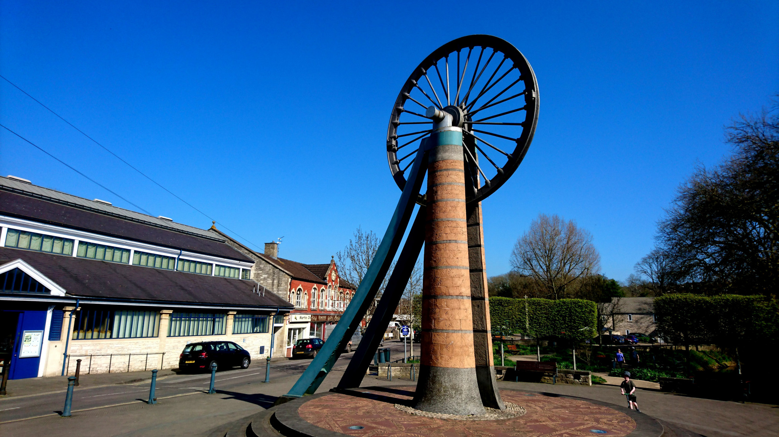

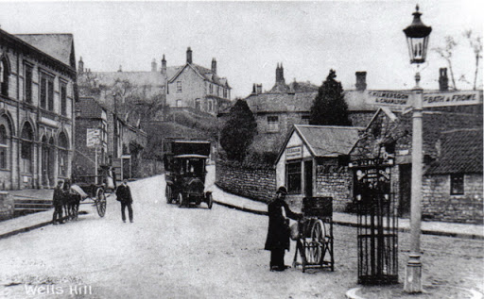

**Class 1 Newsletter**

**Term 4 2020**

Dates for this term

World Book Day - Thursday 5th March

Parents Evening – Tues/Wed 17/18th March

Dance Umbrella – Wednesday 25th March

Trip to Radstock Museum – Thursday 26th March am

What we are learning

Can’t believe that we are already well into our Term 4 topics. Our main topic for this term is called *What’s Under Our Feet* and it’s a local area study primarily looking at how Radstock used to be a thriving mining community and how it – and it’s people – have changed since then. We have already had a taste of what life would have been like as a Victorian child at school and we will be finding out more about how life was very different for children. To consolidate our learning, we will visit Radstock museum and see what life for a miner would have been like.

We are reading The Lighthouse Keeper’s Lunch in Literacy and using *Talk for Writing* strategies to develop our extended writing. The children in the class are becoming much more independent writers and it’s great to see their development. We will also use the book as a springboard to write instructional texts as our non-fiction genre.

In maths, we have started the term with subtraction within 20. We also have two units on measurement: length/height and weight/Volume. Also, the children love using Mathletics in class sessions and there’s always lots for them to do on this online programme at home; look out for set tasks. One of our key maths objectives for Year 1 is to be familiar with 2, 5 and 10x tables and to be able to start to recall facts e.g. 3X2=6 or 3 lots of/groups of 2 are 6.. If you can find any time to practise these – by counting up from 0 in these intervals, then that would be great to accelerate your child’s learning.

For RE, we will be finding out about how important Easter is for Christians and how it signifies a time of Salvation.

In Art, our main focus is on drawing. We will use the work of LS Lowry to focus our learning which will tie nicely into our topic as Lowry was famous for painting scenes of life in industrial districts. Our final pieces will depict the Radstock wheel.

PE this term will be a mixture of gymnastics and multi-skills on Mondays and Wednesdays.

Termly Reminders

Please can you make sure that your children have their **PE kits in school** **at all times**. We are finding that a number of children are regularly without PE kit and therefore cannot always access this area of the curriculum dressed appropriately. **The children’s PE kit should include a white t-shirt, black shorts and daps or trainers for outdoor activities, as well as jogging bottoms and a sweatshirt for the cold weather. We will be doing P.E.sessions outside wherever possible.**

As always - please, please can you make sure all items of clothing are named! Children are always misplacing their jumpers or cardigans and once named they are so easy to return to their rightful owner!

Homework in Year 1 is still **reading daily** and writing a comment or simply signing the children’s reading folder so we know that the book has been read. We will also be sending home some phonics words for you to look at with your child to practise reading.

If you would like to find out more about the Phonics taught in Year 1 beforehand and to access interactive games and printable resources, then go to

<https://www.theschoolrun.com/english/phonics>

Teach Your Monster to Read is still a firm favourite with the class too.

Please feel free to speak to us before or after school.

And finally…

We are very excited that our outside area is going to be transformed (weather permitting) over the Easter holidays. This will then provide us with an additional exciting environment and support Year 1 learning and development.

Watch this space…!