This term’s Christian value is COMPASSION. We are thinking about being a good neighbour, putting on the right attitude and having the courage to care.
School diary dates:
December
Weds 13th 2.00 & 6.00 Nativity performances
3.00 raffle
Fri 15th 9.15 am Carol Concert
2.30 end of Term 2
January 2018
Tues 2nd SCHOOL CLOSED – INSET DAY 2
Weds 3rd children return to school for Term 3
Guitar lessons start

Clothe yourselves with compassion, kindness, humility, gentleness and patience.

Colossians 3.12

Congratulations to last week’s Achievers!

Class 1 Star of the week – Leia

Bradley for always doing his best

Class 2 Riley for amazing morning work

Class 3 Poppy & Olivia for trying so hard to learn their common exception words

Class 4 Elsie for fantastic work in English

Class 5 Suzy for showing determination in maths

Class 6 Alfie for an amazing mandala – full of rotational symmetry

Others: Shylah, Alissa, both Leahs, Lola & Isaac for looking out for Olivia at the Christmas disco party – thank you!

Times Tables Stars: Bronze: Carmel

HOUSE: Fire

Nativity Performances

TODAY at 2pm and 6pm

A HUGE thank you to the staff and children for their commitment to perfecting our Nativity this year – The Donkey Seller.

Last chance to sell your Christmas raffle tickets. The draw will take place after the afternoon performance of the Nativity – TODAY 3.00 in the school hall.
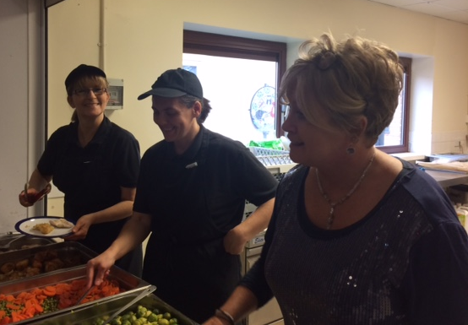
Christmas Lunch

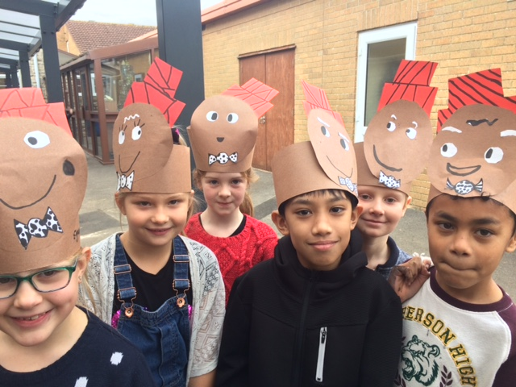
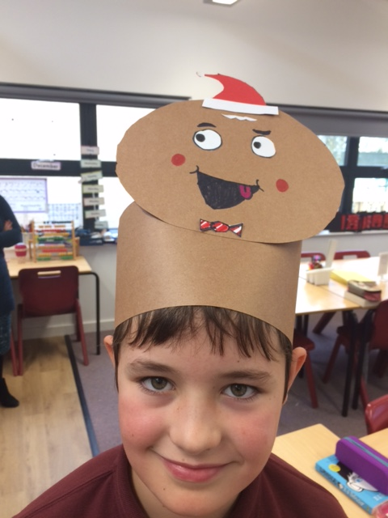
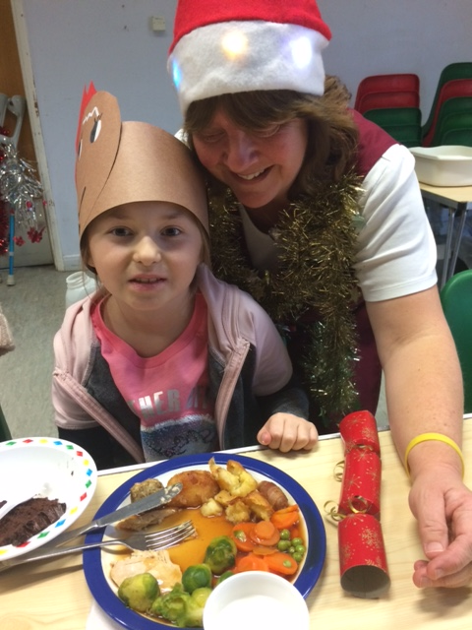
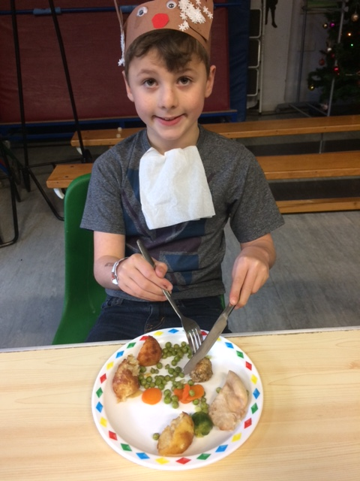

Virtually the whole school had fun fun fun at the Christmas party disco last week! The funds raised were sent to the YYY Foundation – the charity re building schools in Nepal following the devastating 2015 earthquakes. Classes 5 & 6 have been following the progress of the mountain biking team who recently cycled 400km across the Himalayas to help raise £25 000.

Dear Mrs. Jones and your amazing school
That is such a fantastic effort raising funds for YYY Foundation. Thanks so much for your generosity. The total is going far beyond expectations due to efforts like yours.
Thanks so much again,
John Hall
Cycling Team Leader

Notices & Reminders:

Advice from BANES re Early Years funding:
Now is the time for families to check their eligibility for the 30 hours funding for the Spring term 2018. The official date from HMRC for rechecking/applying for codes is 31st December but they are expecting a huge demand on the checking system at the end of December, so advice is not to leave it until then. If you have any problems, contact HMRC on 0300 123 4097. You must apply for your code prior to the 31st December 2017 for the Spring term.
Reminders to re-confirm - some of the HMRC reminders to reconfirm codes have not been received by parents, so do make a note of when your code will need to be reconfirmed.

Call the helpline - if you experience problems with the online application (or re-confirmation process), please go to

the helpline: 0300 123 4097.

SCHOOL MEALS SUPERVISORY ASSISTANT
Starting salary £7.88 / hour – 6.25 hours / week
Required with immediate effect, a member of staff to join our happy, hardworking team, with a focus on PLAY! We are looking for someone able to build on the present foundations of a strong school community working together to raise standards for all of our children. This Playworker / SMSA will work every lunch-time with children from Reception to Year 6, including leading children in structured play activities. We will be particularly interested in finding out where your strengths and interests lie. Flexibility and adaptability are also useful traits!
Please call in at the office or email us for further information and details on how to apply. Our school operates a safe recruitment policy: the successful candidate will need a Disclosure and Barring Service check prior to taking up post.
Closing date: Friday 15th December

