**St Mary’s C of E Primary School, Writhlington**

*‘Inspiring Learning Together’*

**Scheme of Work + Knowlegde Organiser**

The Stone Age!

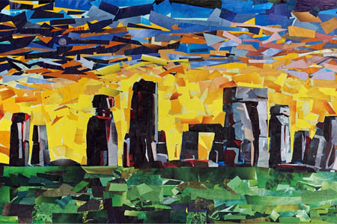

**Key Vocabulary:**

|  |  |
| --- | --- |
| **Spelling** | **Definition/Sentence** |
| collage | A piece of art created by using a range of different materials |
| sculpture | A three-dimensional art form |
| sketch | a rough or unfinished drawing or painting, often made to assist in making a more finished picture |
| tone | lightness or darkness of a colour |
| texture | the feeling, appearance or consistency of an object or material |
|  |  |
|  |  |

**The Learning Journey:**

**Can I create texture?**Children will experiment with their pencils to create texture in different ways.

**Can I create a sketch of Stonehenge?**Children will sketch their image of Stonehenge and add texture using the skills learned in the previous lesson.

**Can I create a collage of Stonehenge?**   
Children will use their sketches from last lesson to create a final piece.

**Can I sculpt a Stone Age house?**Children will plan and create their own 3D model of a Stone Age house using a range of different materials, both natural and manmade.

**Can I create a cave painting?**Children will make their own paint in order to create their own cave paintings just like in the Stone Age.

**Can I create Stone Age jewellery?**Children will use salt dough to create necklaces based on those seen in the Stone Age.

**Wider Curriculum** (Cooking, trips, outdoor):  
Children will take part in a Stone Age day where they will dress up, scavenge, cook and create sculptures linked to the Stone Age.

Children will:

Create sketch books to record their observations and use them to review and revisit ideas

Improve their mastery of art and design techniques, including drawing, painting and sculpture with a range of materials (for example, pencil charcoal, paint and clay)

