St Mary’s C of E Primary School, Writhlington
‘Inspiring Learning Together’
Scheme of Work + Knowledge Organiser
National Curriculum Knowledge outcomes:
- planning different types of scientific enquiries to answer questions,
- taking measurements, using a range of scientific equipment, with increasing accuracy and precision
- using simple models to describe scientific ideas
- reporting and presenting findings from enquiries, including conclusions, causal relationships and explanations of results, in oral and written forms such as displays and other presentations
- identifying scientific evidence that has been used to support or refute ideas or arguments.

The Learning Journey:
To explain how light travels
To explain how light is reflected
Making a periscope to explore reflection.
To investigate refraction
Using prisms.
To explain how a prism affects a ray of light.
To investigate how light helps us see colours
Making a colour wheel.
To explain how shadows are formed.
To understand how the size of shadows changes relative to distance from a light source
To present to the class a short shadow puppet show.
To observe phenomena related to light and how we see
To record what they observe
A carousel of activities to investigate.

Key Vocabulary:
Spelling | Definition/Sentence
light | Natural agent which stimulates sight and makes things visible
Periscope | A tube with mirrors or prisms attached so that you can see things which might be out of sight otherwise.
reflection | The throwing back of a surface of light, heat or sound without it being absorbed.
refraction | The bending of light as it moves from one substance to another.
spectrum | A band of colours (seen in rainbows) produced by the separation of the components of light.
filter | Passing something through a device to remove unwanted material (liquid, gas, light or sound)

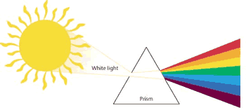
Wider Curriculum (Cooking, trips, outdoor):
making periscopes, art – learning about colours
Science – light

