**St Mary’s C of E Primary School, Writhlington**

*‘Inspiring Learning Together’*

**Scheme of Work + Knowlegde Organiser**

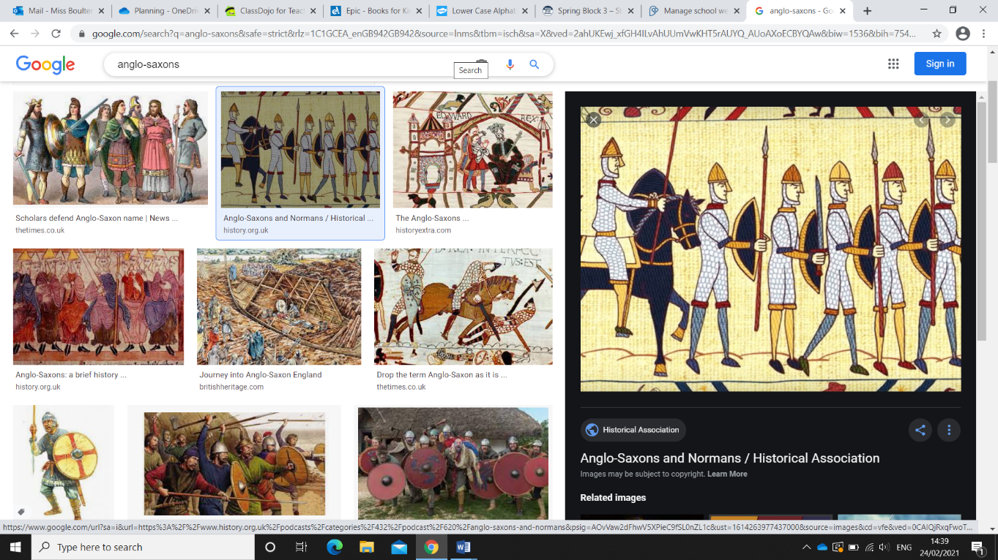

Anglo-Saxons

**Key Vocabulary:**

|  |  |
| --- | --- |
| **Spelling** | **Definition/Sentence** |
| **Invader** | A person or group that invades a country, religion or other place |
| **Settler** | A person who moves with a group of others to live in a new country or area |
| **Succession** | A number of people or things of a similar kind following one after the other |
| **Runes** | A letter of an ancient German alphabet |
| **Alfred the Great** | The king of the West Saxons from 871 to 886 |
| **Paganism** | A term for a great number of spiritual and religious beliefs |
| **Sutton Hoo** | One of the richest sources of archaeological evidence for this period of history |
| **Edward the Confessor** | The penultimate Anglo-Saxon king |
| **Kingdom** | A country, state, or territory rules by a king or queen |
| **Settlement** | A place where people establish a community |

**Wider Curriculum** (Cooking, trips, outdoor):  
Cooking an Anglo-Saxon meal

**Knowledge outcomes:**

* Britain’s settlement by Anglo - Saxons and Scots
* Roman withdrawal from Britain in c. AD 410 and the fall of the western Roman Empire
* Anglo -Saxon invasions, settlements and kingdoms: place names and village life,
* Anglo -Saxon art and culture
* Christian conversion

**The Learning Journey:**

Who were the Anglo-Saxon invaders?

Why did the Anglo-Saxons settle in Britain?

How was Anglo-Saxon Britain rules?

How is Anglo-Saxon life different from Britain today?

Can I explain the impact of Anglo -Saxons on Britain through my understanding of place names?

Can I explore the significance of Sutton Hoo?

How did the Anglo-Saxons find out about Christianity?

Can I compare and contrast everyday meals in Anglo-Saxon times with today?