St Mary’s C of E Primary School, Writhlington
‘Inspiring Learning Together’
Scheme of Work + Knowlegde Organiser
Key Vocabulary:
Sexual: the production of new living organisms by combining genetic information from two individuals of different types (sexes).
Asexual: reproduction which does not involve the fusion of sex cells, the offspring inherit the genes of that parents.
Reproduction: is the biological process by which new individual’s organisms – “offspring”.
Monotreme: reproduce by laying eggs.
Marsupial: offspring are born while they are still in the embryonic stage, they crawl to a pouch on the surface of their mother’s body and remain there until they complete their development.
Placental: where an organ called the placenta grows to sustain the fetus while it grows inside the mother’s uterus.

Picture or illustration: 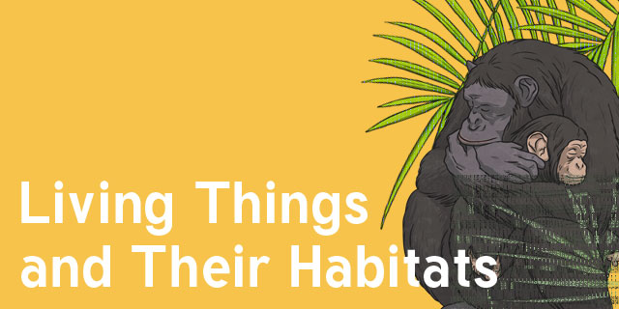
Wider Curriculum (Cooking, trips, outdoor):
- Explore plants in our local area, including the greenhouse at school.
National Curriculum:
- Describe the differences in the life cycles of a mammal, an amphibian, an insect and a bird.
- Describe the life process of reproduction in some plants and animals.
The Learning Journey:
Can I explain the difference between sexual and asexual reproduction?
- Children will be looking at different ways plants reproduce, recapping subject knowledge about parts of the plant from year 3.
Can I identify advantages and disadvantages to sexual and asexual reproduction in plants?
- Explore asexual reproduction through experience. Children will take cuttings from a geranium plant, and plant them to see if they develop roots- these will be genetically identical to the parent plant.
Can I describe the life cycle of a mammal?
- Look at the different life cycles of three different mammals (a monotreme, a marsupial and a placental)
Can I describe and explain Jane Goodall’s work with chimpanzees?
- Children will explore Jane Goodall’s work and endangered species and the threats they face in the wild.
Can I explain metamorphosis and give examples?
- Children discuss similarities and differences between the life cycles they learnt about and identify animals that go through metamorphosis.
Can I describe the similarities and differences between plants and animals life cycles?
- Children order the stages of the life cycle of a bird and compare it with a will known plant. Children take on the role of wildlife presents and script a narrative demonstrating all of their understanding.
Living things and their habitats.

