St Mary’s C of E Primary School, Writhlington
‘Inspiring Learning Together’
Scheme of Work + Knowlegde Organiser
Oracy:

Sharing to various classes how we can help save the rainforests. Top 5-10 tips.

Ensure discussions are based around using our oracy guidelines and providing children stem sentences to use.
The Learning Journey:

Can I locate the Amazon rainforest?
This lesson will elicit children’s knowledge about the rainforest and look at the location of rainforests around the world.

What is the rainforest climate like?
Children will create weather forecasts for the Amazon rainforest and learn the difference between climate and weather.

Can I describe and understand the features of the layers of a rainforest?
Children will look at the different layers of the rainforest, creating their own for the classroom.

Can I research different animals living in the Amazon?
Children will create fact files for different rainforest creatures.

What is deforestation and what effects does it have on our rainforests?
Children will consider both the positive and negative effects of deforestation on the rainforest from different perspectives.

Can I suggest ways to help save our rainforests?
Children will take part in a scavenger hunt to look for different ways to help save the rainforest. In groups, children will create an information page to promote ways to save our rainforests.
Key Vocabulary:
Spelling | Definition/Sentence
equator | An imaginary line which divides the earth into two parts, the Northern and Southern hemisphere
climate | The average measurements of temperature, wind, humidity, snow, and rain in a place over the course of years
deforestation | The clearing, or cutting down, of forests
biome | A large naturally occurring community of flora and fauna occupying a major habitat
flora | The plants of a particular region or habitat
fauna | the animals of a particular region or habitat

Knowledge outcomes:
Identify the position and significance of Equator and the Tropics of Cancer and Capricorn

Describe and understand key aspects of: physical geography, including: climate zones, rivers, mountains, volcanoes and earthquakes, and the water cycle
Use maps, atlases, globes and digital/computer mapping to locate countries and describe features studied

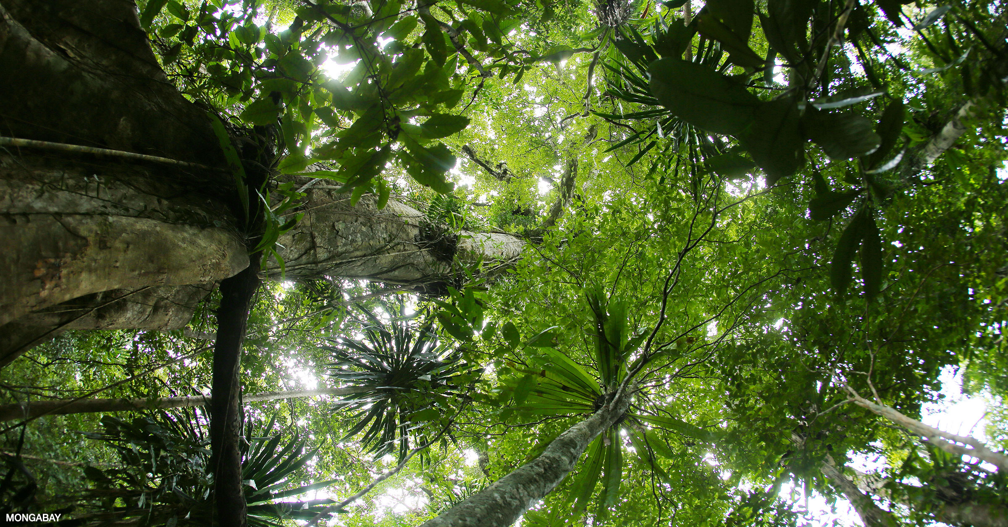

South American Rainforest

