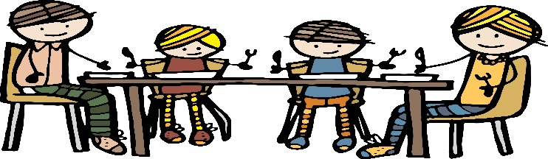

**Class 2 Newsletter**

**Term 2 2019**

What we are learning

Our topic for this term is ‘Back in Time for Dinner’. Just like the BBC2 programme we will embark on an extraordinary time-travelling adventure to discover how our experience of food has changed over the last 100 years. The children will have the opportunity to cook and sample a range of traditional dishes from the past as well as finding out where our food has come from and how shopping habits have changed.

In Literacy we will begin by learning the story ‘The Disgusting Sandwich’ by Gareth Edwards. The children will write their own stories about a disgusting food, based on the structure of the original story. The food theme will continue through our non-fiction writing, which will focus on recipes, while in poetry we will be exploring classic poems.

This term in Maths we will be learning various methods of calculating addition and subtraction problems. Towards the end of the term the children will explore money and solve real-life problems, including paying for items and giving change.

Our learning in Science will focus on ‘Animals, Including Humans’. The children will learn about how humans and other animals are born, grow and change, and what we need to survive and be healthy.

In Design and Technology the children will be investigating how to work with fabric. They will design and make their own bunting. They will be given the chance to explore different fabrics that they could use to enhance their designs. Using techniques such as sewing, stapling and gluing, children will decorate their felt flag. Finally, they will evaluate their product.

The RE unit this term is ‘Special Places’. We will be finding out what this means within Christianity and the Hindu religion.

Dates for this term

10th December – Key Stage 1 Nativity

11th December – Christmas Fayre

17th December – Pantomime @ Theatre Royal, Bath

19th December – End of Term 2:30pm

More news

Learning to read is one of the most crucial skills your child will learn, while at primary school. Being able to read words and understand what is being read not only enables children to enjoy a wide range of stories and poems, it allows them to learn new facts, understand things that they need to do and access the rest of the curriculum. Reading opens up a whole world of ideas and opportunities. We therefore encourage all children to read every day in order to practice and develop the skills needed to become a fluent and competent reader. To encourage this further in Class Two, we are launching ‘Reader of the Week’. We will be monitoring how much your child reads at home across the week, by using their reading records as a guide and awarding Reader of the Week, based on effort made. We hope that you will support us in this by regularly listening to your child read at home and signing their reading record each time.

 Ho! Ho! Ho! Yes, Christmas is coming, which can only mean one thing – the Key Stage 1 nativity! As always, we appreciate all your support with this, especially costumes. You should receive a letter very soon with regards to costumes.

Reminders

It’s great to see so many children completing their homework each week. Please encourage your child to keep it up as it benefits them greatly by consolidating their learning in class that week.

Please remember that PE Kits are needed in school **every day.** Without the right kit it is very hard for your children to enjoy the full curriculum within school.

And finally….. As the children are now settled into class 2 and are becoming much more independent, it is of great benefit to them when parents say goodbye in the playground and allow them to enter the classroom on their own. The children are then able to settle at their tables quicker and begin their learning for the day. Please encourage your child to do this every day.

**Thank you for your continued support.**