St Mary’s C of E Primary School, Writhlington
‘Inspiring Learning Together’
Scheme of Work + Knowlegde Organiser
Key Vocabulary:
Spelling | Definition/Sentence
Stone Age | period of time lasting around 3 million years whereby stone was widely used
Bronze Age | period of time characterised by the use of bronze
Iron Age | period of time characterised by the use of iron
Palaeolithic | the Old Stone Age
Mesolithic | period of time between Palaeolithic and Neolithic
Neolithic | the New Stone Age

Wider Curriculum (Cooking, trips, outdoor):
Stone Age Day, involving art, cooking and exploring outside.
Knowledge outcomes:
Changes in Britain from the Stone Age to the Iron Age
This could include:
Late Neolithic hunter-gatherers and early farmers, for example, Skara Brae
Bronze Age religion, technology and travel, for example, Stonehenge
Iron Age hill forts: tribal kingdoms, farming, art and culture
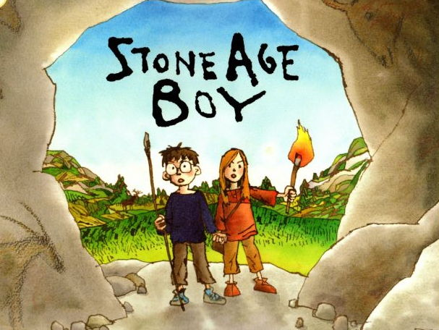
The Learning Journey:
Can I place the Stone Age on a timeline of world history?
Children will look at different events in history, comparing them to the Stone Age and when it occurred in history.
How did people in the Stone Age live?
Children will look at Stone Age life, looking for key information about food and clothing during that period.
How does the Bronze Age differ from the Stone Age?
Children will compare the Bronze Age to the Stone Age, with a focus on what was the same and what was different, and will look into the history of Stonehenge.
How does the Iron Age differ from the Bronze Age?
Children will compare the Iron Age to the Stone Age and gather key information about that time period.
Can I summarise information gathered into a booklet?
The Stone Age – The Iron Age

